1. **CAST OBJECTS TO A DATA TYPE**

SELECT customerNumber,

    COUNT(*) AS number_payments,

    MIN(CAST(amount AS INT)) AS min_purchase,

    MAX(CAST(amount AS INT))  AS max_purchase,

    AVG(CAST(amount AS INT)) AS avg_purchase,

    SUM(CAST(amount AS INT)) AS total_spent

FROM payments

pd.read_sql('''

select cast(round(priceEach) as INTEGER) as rounded_price_int

        from orderDetails

            ''',conn)

**2.Strip year or month from date as a string object**

WHERE strftime('%Y',paymentDate)='2004'

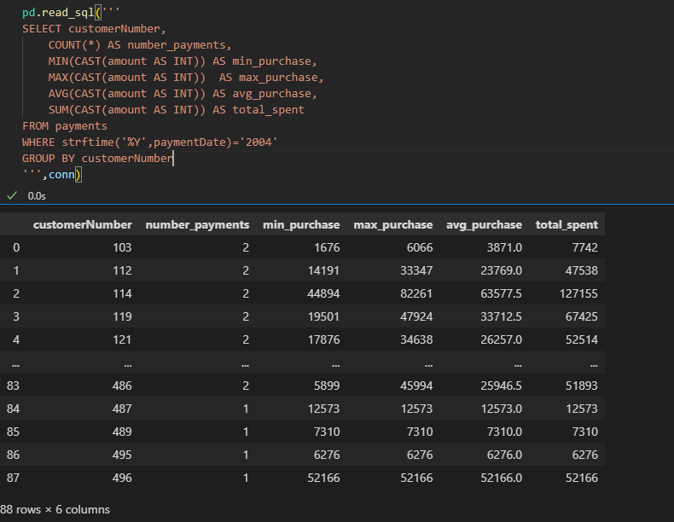

pd.read_sql('''

select orderDate,

            strftime('%m',orderDate) AS month,

            strftime('%Y',orderDate) AS year,

            strftime('%d',orderDate) as day

from orders;

''',conn)

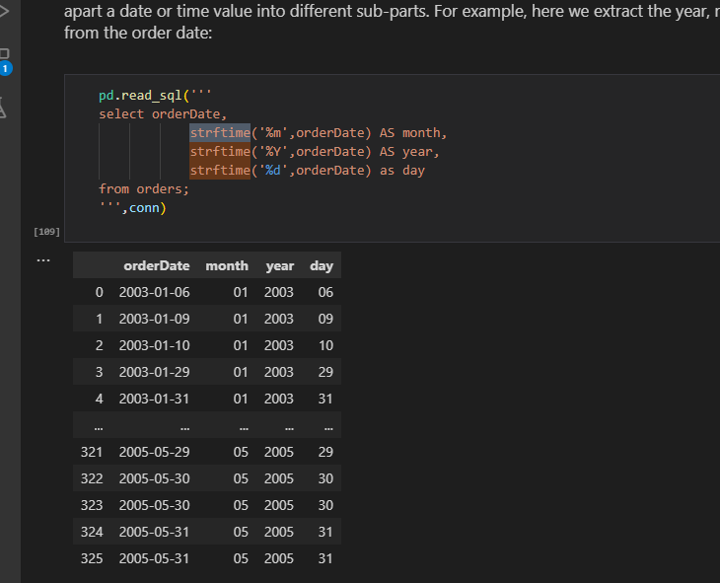

**Or use substr method**

pd.read_sql('''

SELECT customerNumber,

    COUNT(*) AS number_payments,

    MIN(CAST(amount AS INT)) AS min_purchase,

    MAX(CAST(amount AS INT))  AS max_purchase,

    AVG(CAST(amount AS INT)) AS avg_purchase,

    SUM(CAST(amount AS INT)) AS total_spent

FROM payments

WHERE substr(paymentDate,1,4) ='2004'

GROUP BY customerNumber

''',conn)

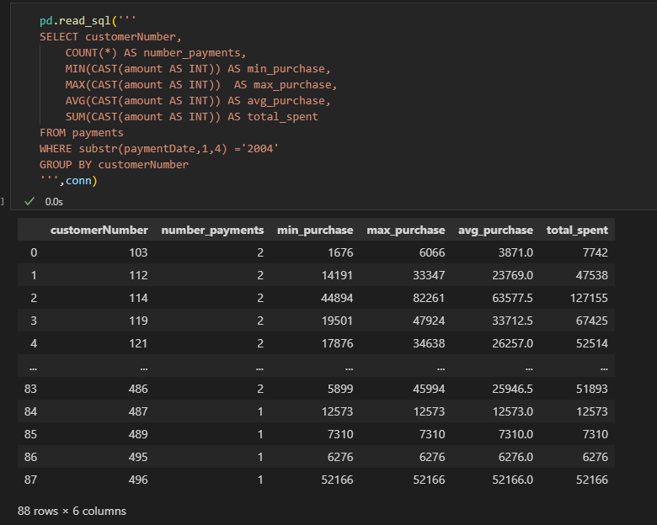

**3.Convert select statement to dataframe**

import pandas as pd

cur.execute('select * from   contactinfo')

df = pd.DataFrame(cur.fetchall())

df.columns = [x[0] for x in cur.description]

df

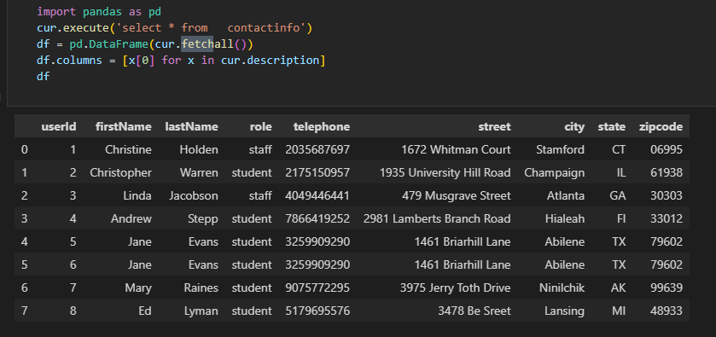

* 4. Highest -**altitude**
* Southern/northern – **latitude eg** northern-most airport is the highest latitude

Southern-most – smallest latitude

**5.Pandasql Error**

**----> 6** passenger_names **=** pysqldf**(**q**)**

**ImportError**: Unable to find a usable engine; tried using: 'sqlalchemy'.

A suitable version of sqlalchemy is required for sql I/O support.

Trying to import the above resulted in these errors:

**- Pandas requires version '1.4.0' or newer of 'sqlalchemy' (version '1.3.19' currently installed).**

**TO update use**

conda update sqlalchemy

Check version if updated

pip show sqlalchemy

6.

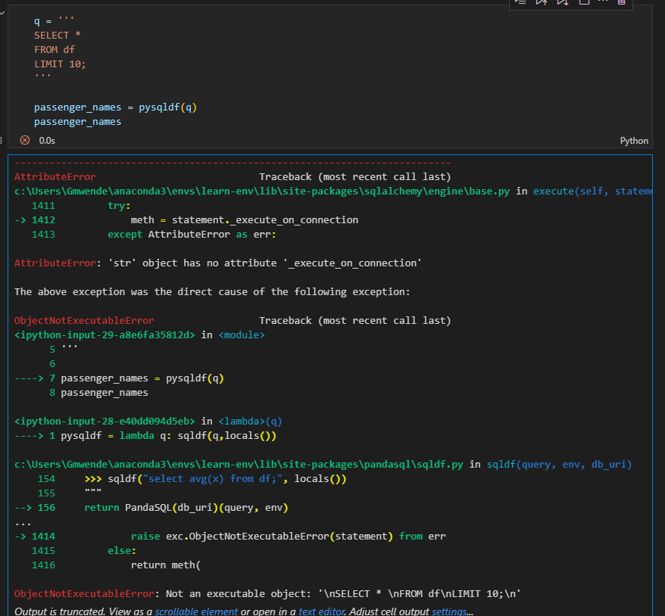

Works well in colab

**7.Put dataframe in memory as to use conn**

#put df to memory

import sqlite3

conn = sqlite3.connect(':memory:')

df.to_sql('df', conn, index=False, if_exists='replace')

# Execute SQL query using the connection

query = "SELECT * FROM df"

result = pd.read_sql(query, conn)

result

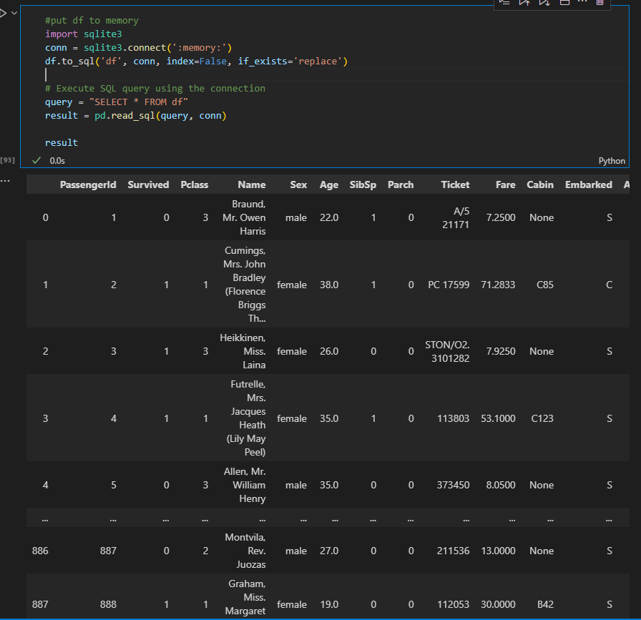

**8.Get female and children that is female and male less than or equal to 15**

df[(df['Sex'] == 'female') | (df['Age'] <= 15)]

**9.Select everyonelse other than 1**

df[df['Pclass'] != '1']

**10.calculate totals using counter(get frequency for each value)**

counter = collections.Counter(x)

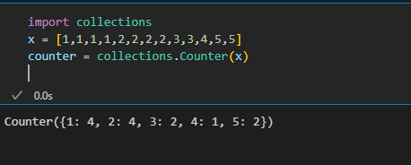

11. **Create two vertical subplots sharing 15% and 85% of plot space**

**Create density instead of count on seaborn histogram**

*#Create two vertical subplots sharing 15% and 85% of plot space*

*#sharex allows sharing of axes i.e building multiple plots on the same axes*

*fig, (ax,ax2) = plt.subplots(2,sharex=True,gridspec_kw={'height_ratios':(.15,.85)},figsize=(10,8))*

*sns.histplot(data['Height'],*

*lw=2,*

*edgecolor='r',*

*alpha=0.4,*

*color='w',*

*label='Histogram',*

*stat='density',*

*ax=ax2*

*)*

*sns.kdeplot(data.Height,*

*lw=3,*

*color='b',*

*label='Kernerl Density Estimation plot',*

*alpha=0.7,*

*ax=ax2*

*)*

*mean = data.Height.mean()*

*std = data.Height.std()*

*parametric_dist = stats.norm(loc=mean, scale=std)*

*x=np.linspace(parametric_dist.ppf(0.01),parametric_dist.ppf(0.99),100)*

*ax2.plot(x,*

*parametric_dist.pdf(x),*

*color='g',*

*alpha=0.7,*

*lw=3,*

*label = 'Parametric Fit'*

*)*

*ax2.set_title('Density Estimations')*

*sns.boxplot(data=data,x='Height',ax=ax,color='r') #sns.boxplot(x=data.Height, ax = ax,color = 'red')*

*ax.set_title('Box and Whiskers Plot')*

*ax2.set(ylim=(0, 0.08))*

*plt.ylim(0, 0.11)*

*plt.legend();*

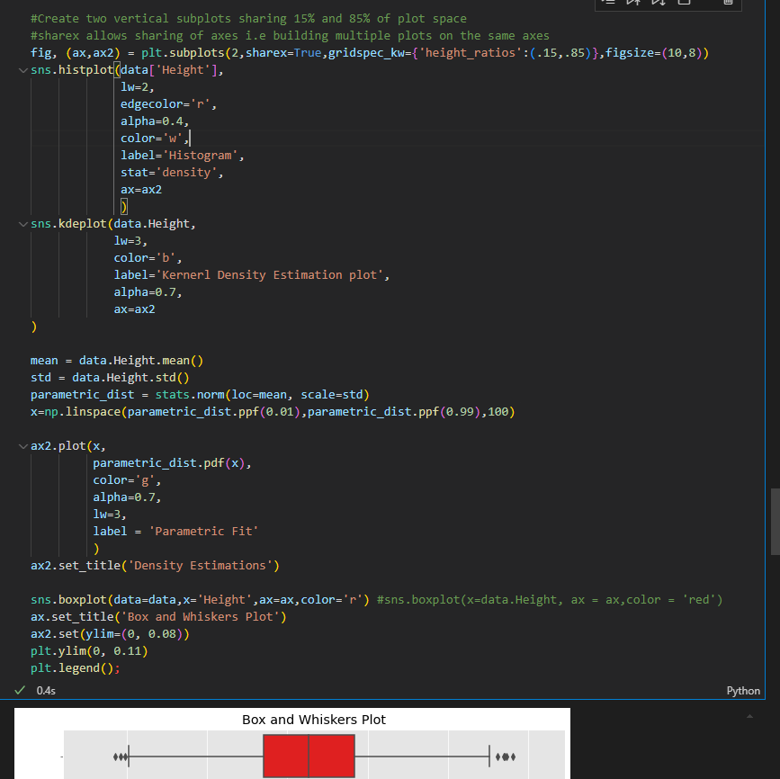

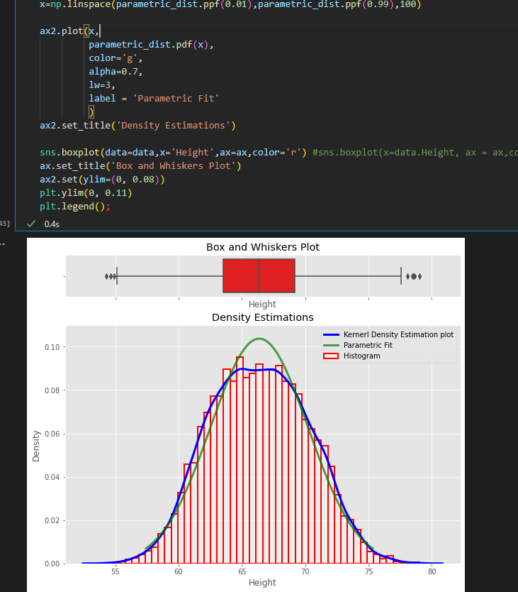

**12. Add density (probability) instead of counts in matplotlib histogram**

xtick_locations = range(1,6)

bins = np.arange(6) +0.5 #[0.5, 1.5, 2.5, 3.5, 4.5, 5.5]

plt.hist(x,bins=bins,rwidth=0.25,density=True)

plt.xticks(ticks=xtick_locations)

plt.xlabel('Bins of Outcomes')

plt.ylabel('Probabilities of Bins of Outcomes')

plt.title("Adjusted Histogram with `density=True`");

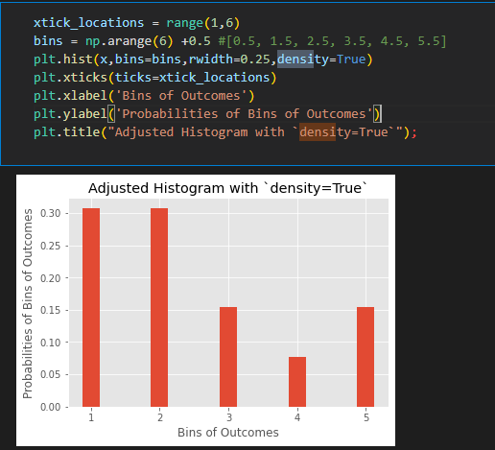

**13. ttest**

t= (x_bar-mu)/(sample_std/np.sqrt(25))

print('t: ',t)

critical_t_value = stats.t.ppf(1-alpha,24)

print('critical_t_value: ',critical_t_value)

p_value = stats.t.sf(t,df)

print("p-value:",p_value)

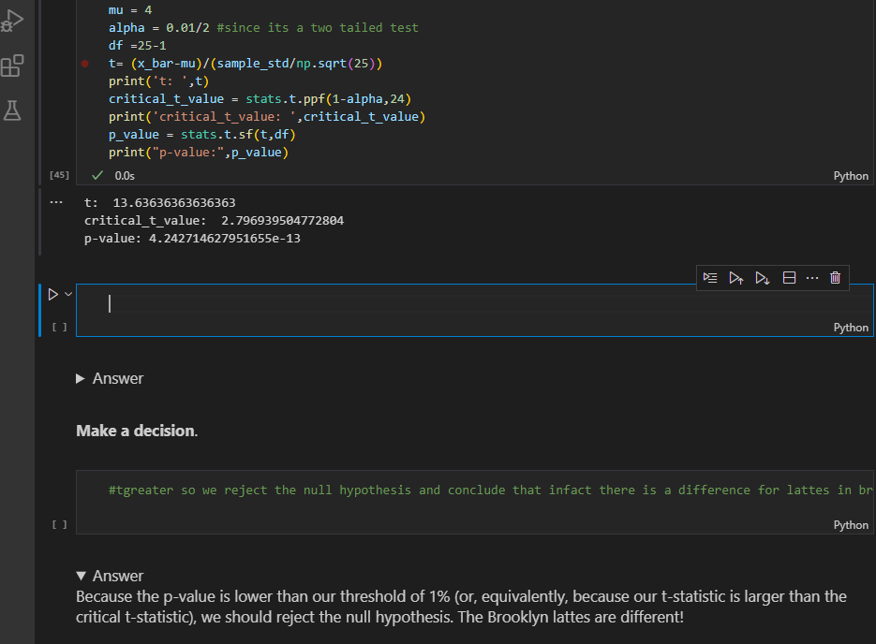

b)Example 2#one tailed left tail

sample =[20, 30, 30, 50, 75, 25, 30, 30, 40, 80]

x_bar =  np.mean(sample)

sample_std = np.std(sample,ddof=1)

n=len(sample)

df=n-1

mu =58

t_stat1 = stats.ttest_1samp(a=sample,popmean=58)

print('t_stat1:', t_stat1[0])

print('alpha:', t_stat1[1]/2)

t_stat2 = (x_bar-mu)/(sample_std/np.sqrt(n))

print('t_stat2:', t_stat2)

alpha2 = stats.t.cdf(t_stat2, df) #used cdf since it is left tail(checking less)

print('alpha2:', alpha2)

t_crit = stats.t.ppf(0.1,df)

print('t_crit:', t_crit)

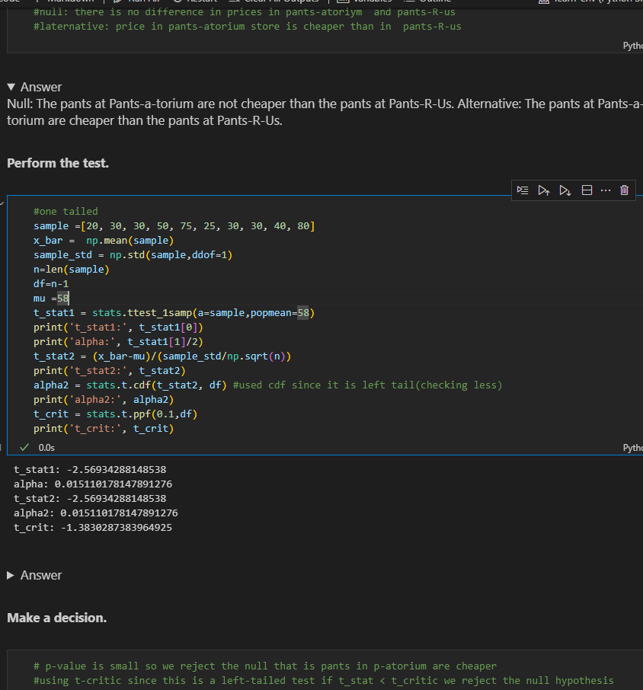

**c)two-sample t-test**

**delivery_times_A = [28.4, 23.3, 30.4, 28.1, 29.4, 30.6, 27.8, 30.9, 27.0, 32.8]**

**mean_A = np.mean(delivery_times_A)**

**std_A = np.std(delivery_times_A)**

**nobs_A = len(delivery_times_A)**

**mean_B = 26.8**

**std_B = 2.6**

**nobs_B = 10**

**stats.ttest_ind_from_stats(mean1=mean_A, std1=std_A, nobs1=nobs_A,**

**mean2=mean_B, std2=std_B, nobs2=nobs_B,**

**equal_var=False)**

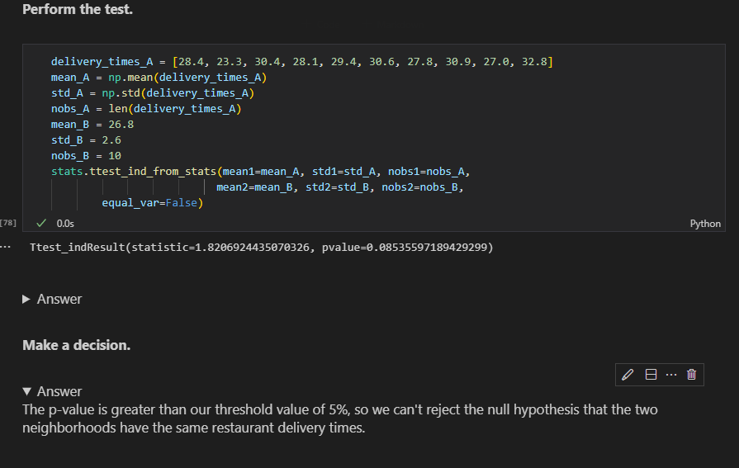

**c)2 sample again two tailed**

**high_protein = [134, 146, 104, 119, 124, 161, 107, 83, 113, 129, 97, 123]**

**low_protein = [70, 118, 101, 85, 107, 132, 94]**

**stats.ttest_ind(a=high_protein, b=low_protein)**

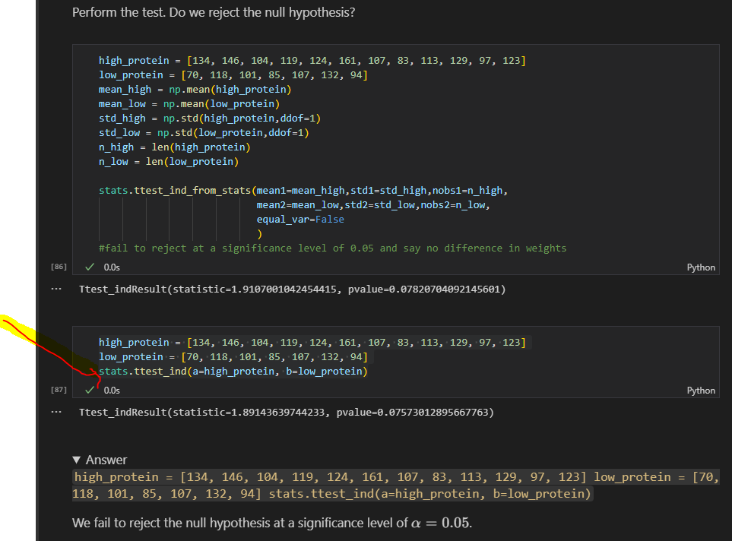

**d)2 sample one tailed**

h_bar = np.mean(high_protein)

l_bar = np.mean(low_protein)

h_df = len(high_protein) - 1

l_df = len(low_protein) - 1

pooled_var = (h_df*np.var(high_protein) + l_df*np.var(low_protein)) / (h_df + l_df)

t_stat = (h_bar - l_bar) / np.sqrt(pooled_var * (1/len(high_protein) + 1/len(low_protein)))

t_stat

stats.t(df=h_df+l_df).cdf(t_stat)

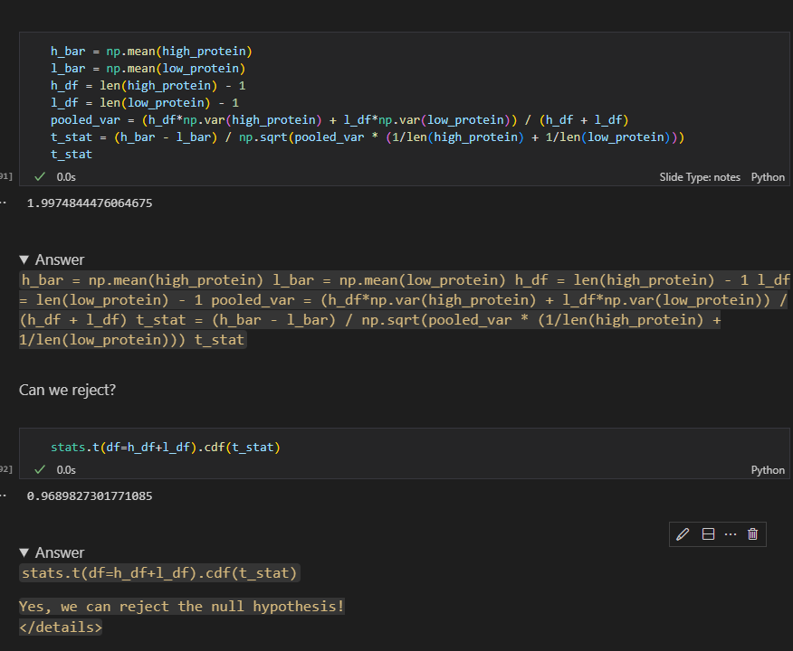

**SQL SUMMARY**

* We will primarily use SQLite in these lessons because it is lightweight and portable (and therefore useful for educational purposes)
* SQLite is a C library that provides lightweight disk-bases databse that doesn’t require a separate server process and allows accessing the database using a nonstandard variant of the SQL query language.
* Some applications can use SQLite for internal data storage.Its also possible to prototype an application using sqlite and then port the code to a larger databse such as postresgreSQL or Oracle

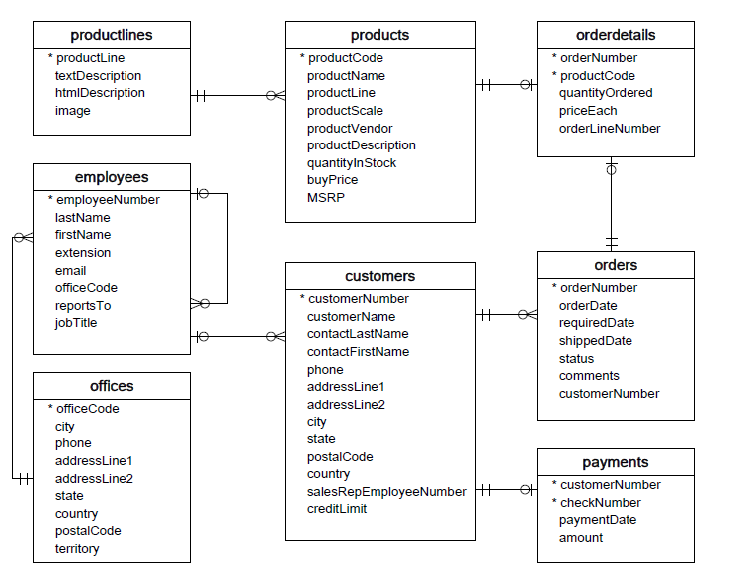

1. **ERD** (Entity Relationship Diagram)- shows the relationship between tables. It does not give us any information about the specific data stored in the database, but rather the metadata
2. **Connect to sqlite 3**

import sqlite3

conn = sqlite3.connect('data.sqlite')

1. **Select Records**

q='''SELECT * FROM EMPLOYEES'''

pd.read_sql(q,conn)

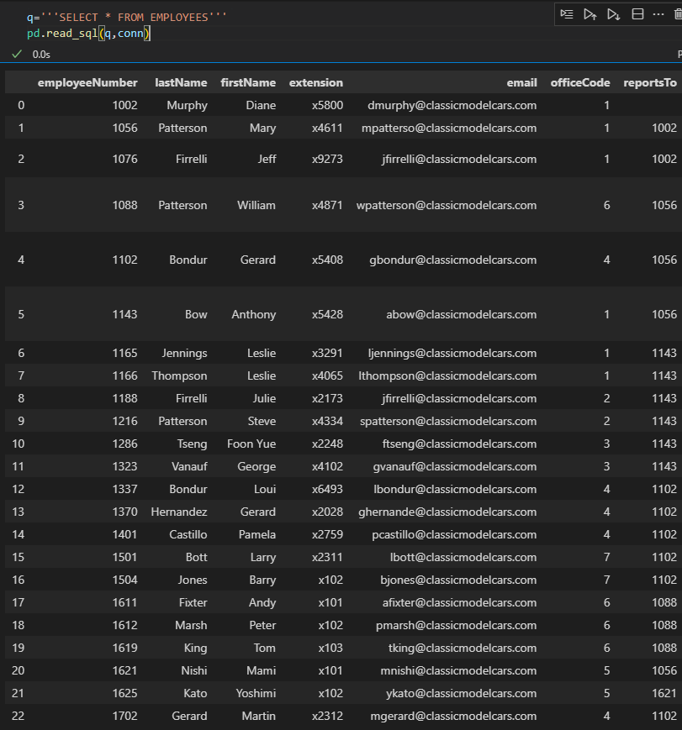

1. Check table in a database(Note that the .execute() method didn't actually return our data. The data is now just available in our cursor object. We'll use the .fetchall() method to get all the rows from our query.)

cur = conn.cursor()

cur.execute("""SELECT name FROM sqlite_master WHERE type = 'table';""")

table_names = cur.fetchall()

table_names

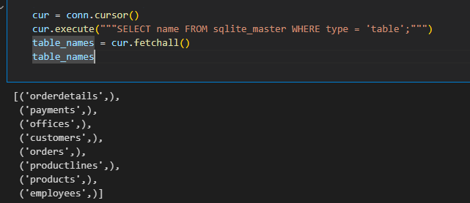

1. Select * using cursor or can use ‘curr.execute(''' select * from offices''').fetchall(),

curr.execute(''' select * from offices ''')

curr.fetchall()

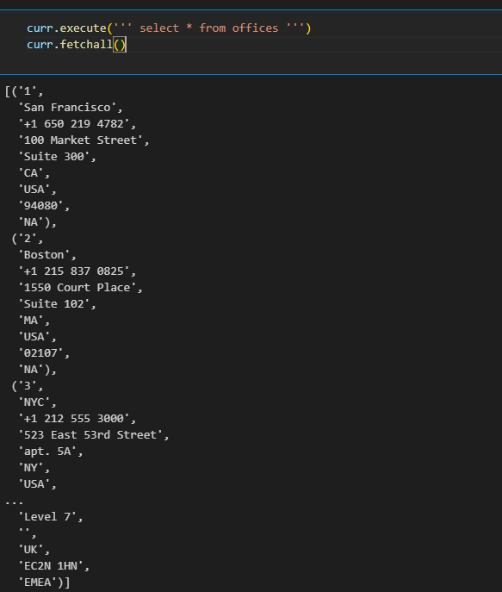

1. curr.execute(''' select * from offices''').fetchall()[0][2]

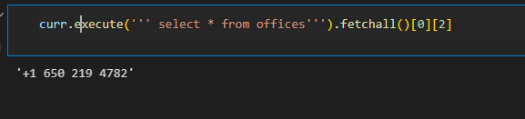

1. Viewing column names(  
   Looks like we got some data, but it's not clear what each element represents. We can view the column names in the cursor's description attribute.)

curr.description

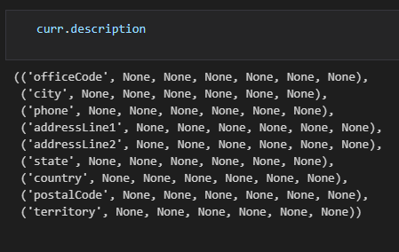

1. Create a dataframe with column names from the records/from a table

import pandas as pd

pd.DataFrame(

    data = curr.execute(''' select * from offices;''').fetchall(),

    columns =[x[0] for x in curr.description]

)

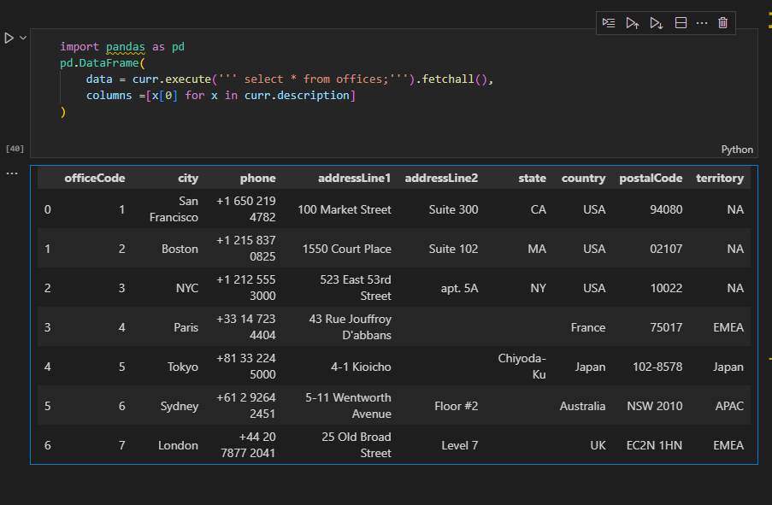

1. Retrieving a subset of columns

pd.read_sql('''

      select lastName,FirstName from employees

            ''',conn).head()

1. Use Aliases (AS keyword) to change column names

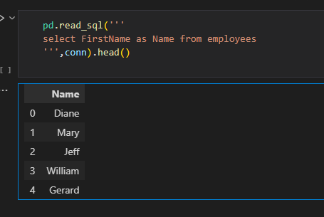

1. Using SQL case statements

pd.read_sql('''

select Firstname,LastName,jobTitle,

            CASE

            WHEN jobTitle = 'Sales Rep' then 'Sales Rep'

            ELSE 'Not Sales Rep'

            END AS role

From employees

''',conn)

1. Cases to make Human Readable

pd.read_sql('''

select FirstName,lastName,officeCode,

            CASE officeCode

            WHEN '1' then 'San Francisco, CA'

            WHEN '2' then 'Boston, MA'

            WHEN '3' then 'New York, NY'

            WHEN '4' then 'Paris, France '

            WHEN  '5' then  'Tokyo, Japan'

            END as office

from employees

            ''',conn).head(10)

1. a**)Check length**

pd.read_sql('''

select length(firstName)  as name_length

    from employees

''',conn).head(5)

b)**Convert to upper**

pd.read_sql('''

select upper(firstName) as name_in_all_caps

        from employees;

''',conn).head(5)

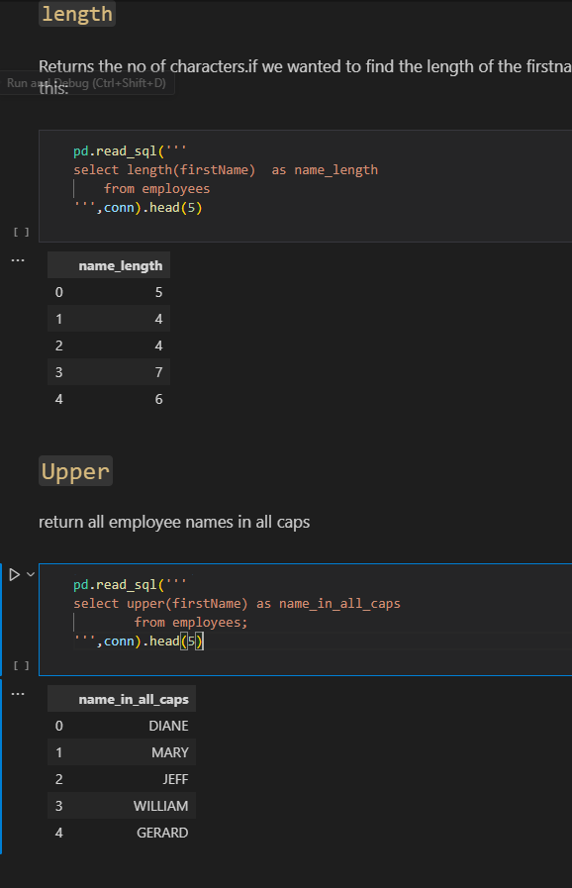

**c)Slicing**

select substr(firstname,1,1) as first_initial

from employees;

select substr(firstName,1,1) || '.' as first_initial     --use || as **concatentate** operator

    from employees

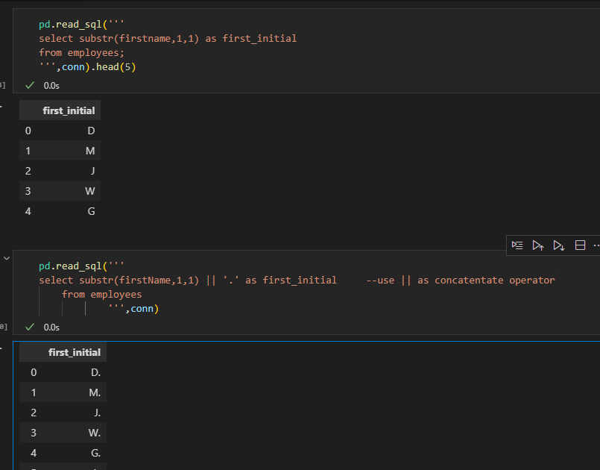

d) We can also **combine multiple column values**, not just string literals

pd.read_sql('''

select firstname || ' ' || lastname as name

from employees

''',conn).head()

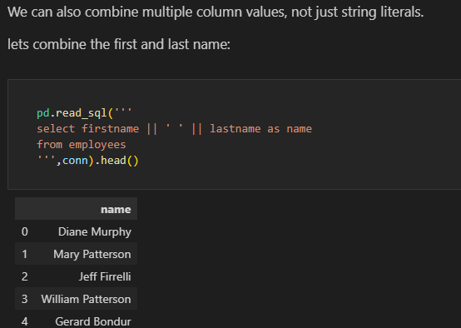

e)**Aggregations eg count**

pd.read_sql('''

select COUNT() as "Number of Airports"

from airports

            ''',con)

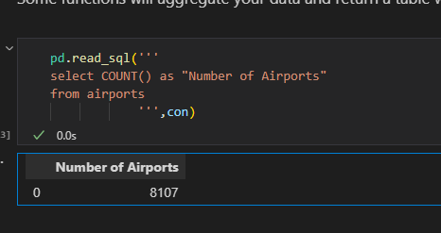

NB: in AGGREGATIONS ensure that’s it’s the correct datatype for the function to avoid unexpected results eg

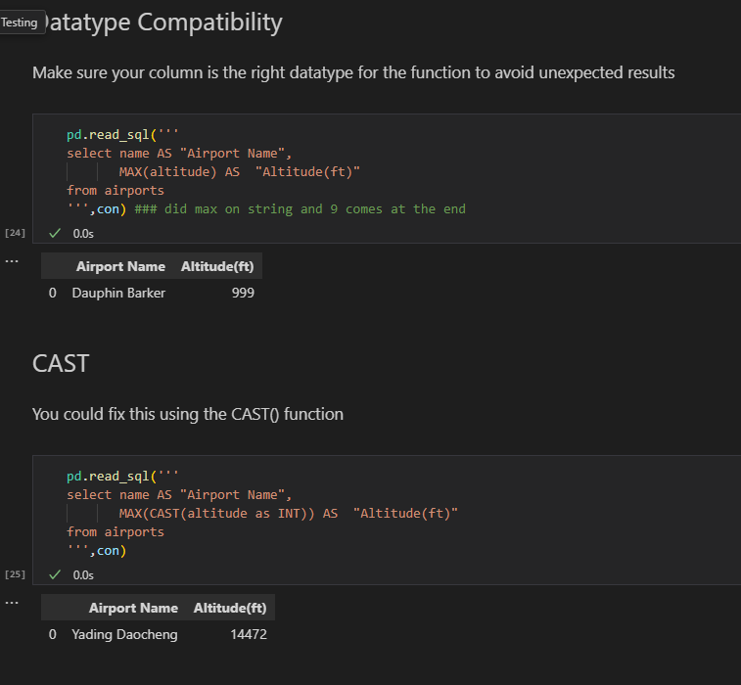

1. **Built in SQL for Math Functions**

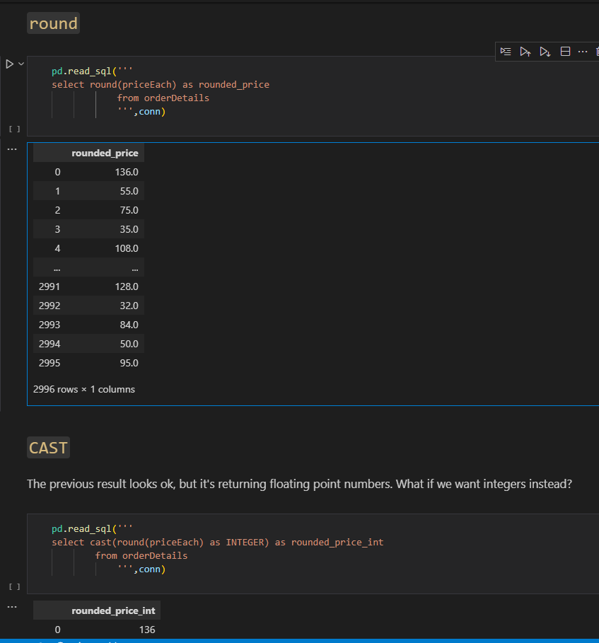

1. **Built-in SQL Functions for Date and Time Operations-**

(JulianDay and Date)

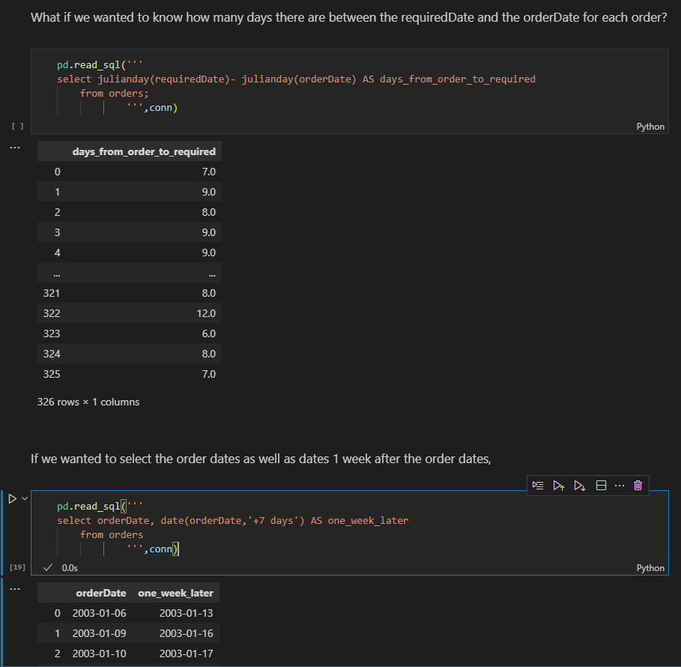

1. strftime function

pd.read_sql('''

select orderDate,

            strftime('%m',orderDate) AS month,

            strftime('%Y',orderDate) AS year,

            strftime('%d',orderDate) as day

from orders;

''',conn)

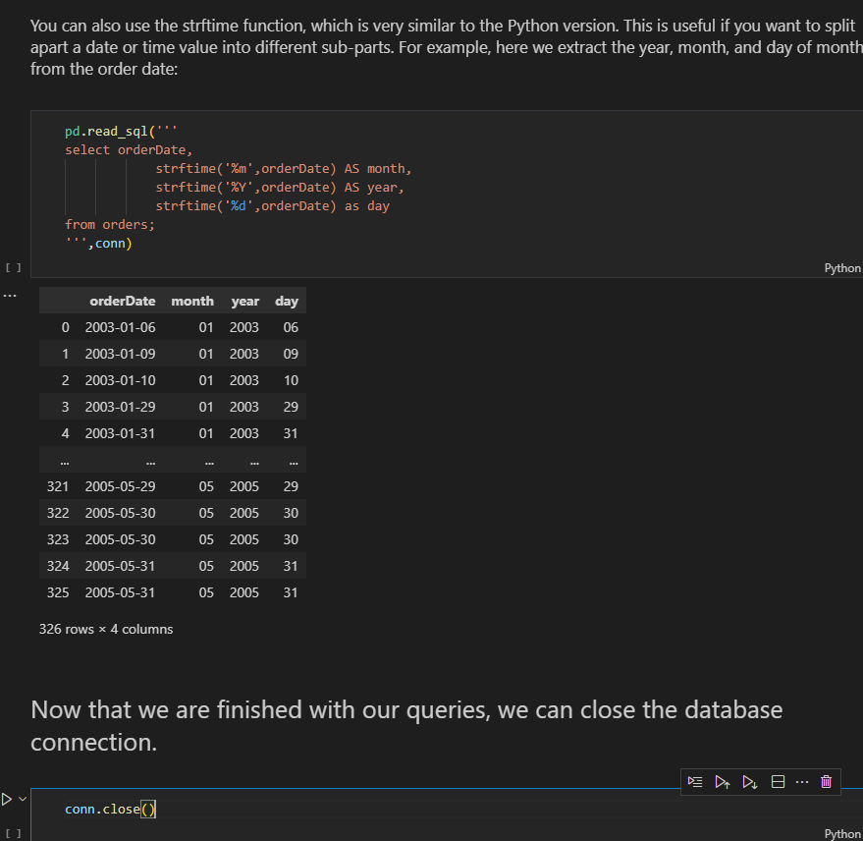

**13. If we really wanted to, we could just use those same SQLite terminal commands directly in a Jupyter Notebook using magic commands.**

%%script sqlite3 data/data.sqlite --out offices_data

select* from offices;

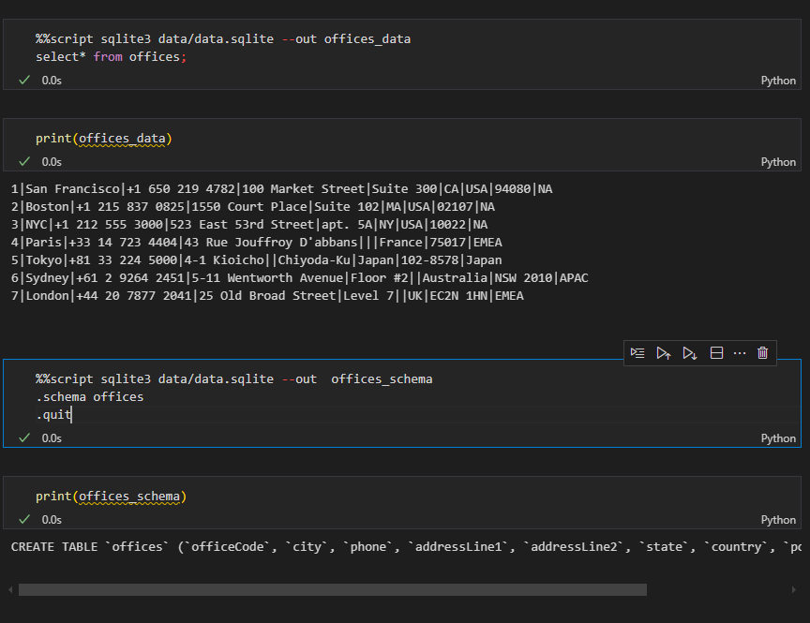

%%script sqlite3 data.sqlite --out tables

.tables

.quit

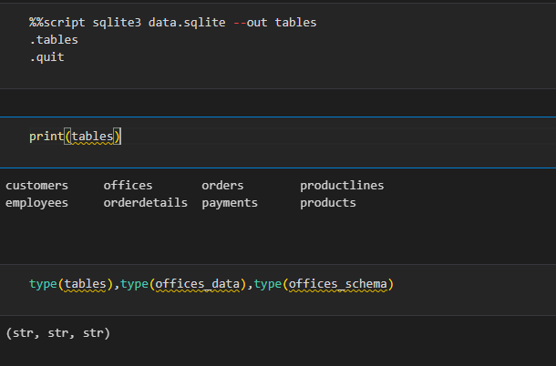

1. Connecting to the database using the terminal

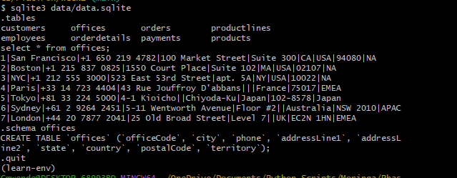

1. **Relational databases** typically have multiple tables containing data, and the tables have defined relationships

Database **Schema** – defines the structure of the database, including the tables and relationships between tables

**Primary key** – uniquely identifies each row in a table

**Foreign key** - used in one table to refer to the primary key of another table

1. Acess schema of lets say the first table

print(schema_df['sql'].iloc[0]) #print(schema_df.iloc[0]['sql'])

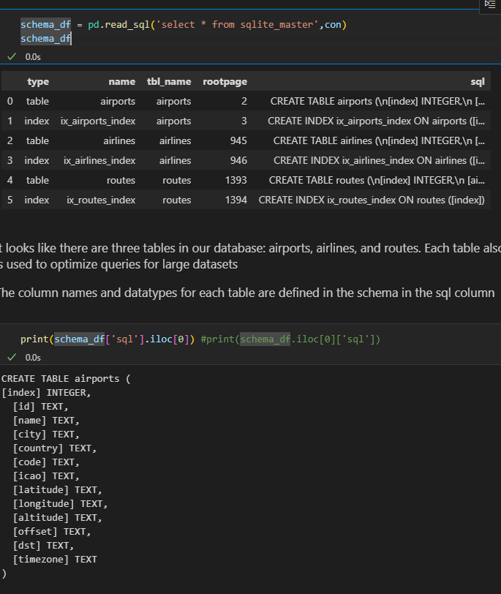

1. **Between**

pd.read_sql('''

SELECT  name AS "Airport Name",

        CAST(latitude AS int) AS "Airport Latitude",

        CAST(altitude AS int) AS "Altitude (ft)"

FROM airports

WHERE "Airport Latitude" between 20 AND 50 AND "Altitude (ft)">10000

''',con)

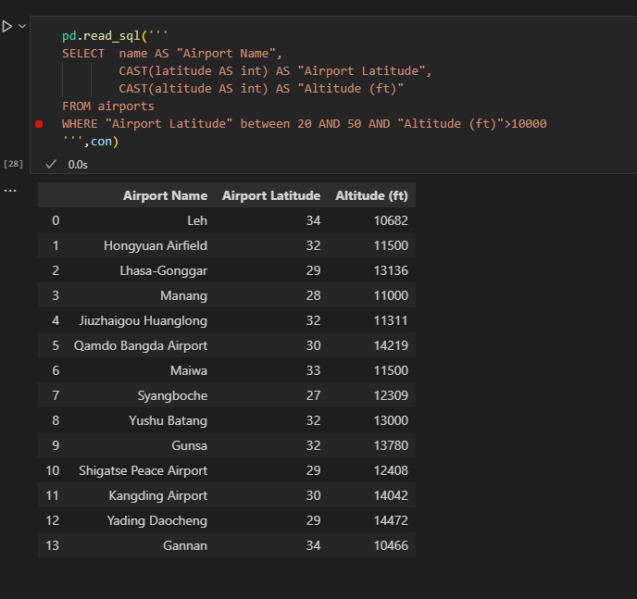

1. **IS** – Useful when working with NULL values

pd.read_sql('''

SELECT name AS "Airport Name",

       code as "Airport Code"

FROM airports

WHERE "Airport Code" IS NOT NULL

''',con)

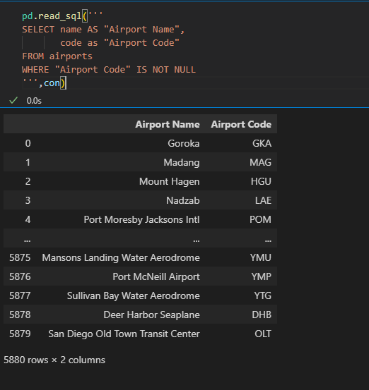

1. **ORDER BY**

pd.read_sql('''

SELECT name AS "Aiport Name",

        CAST(latitude AS int) AS "Airport Latitude",

        CAST(altitude AS int) AS "Altitude(ft)"

FROM airports

WHERE "Altitude(ft)" >=10000

ORDER BY "Airport Latitude" DESC,

         "Altitude(ft)" DESC

 ''',con)

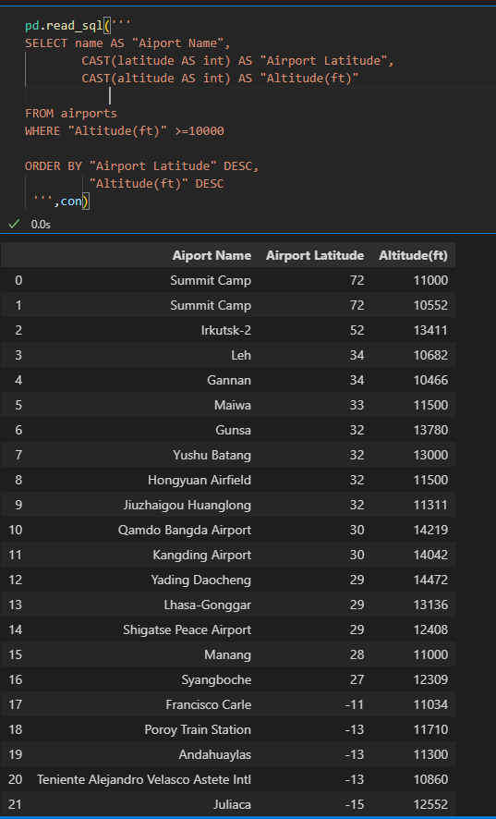

1. **LIMIT**

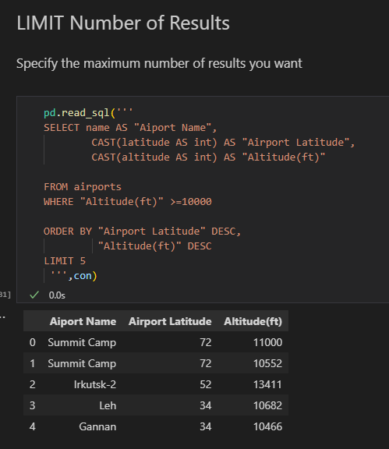

1. **a)Filtering by price**

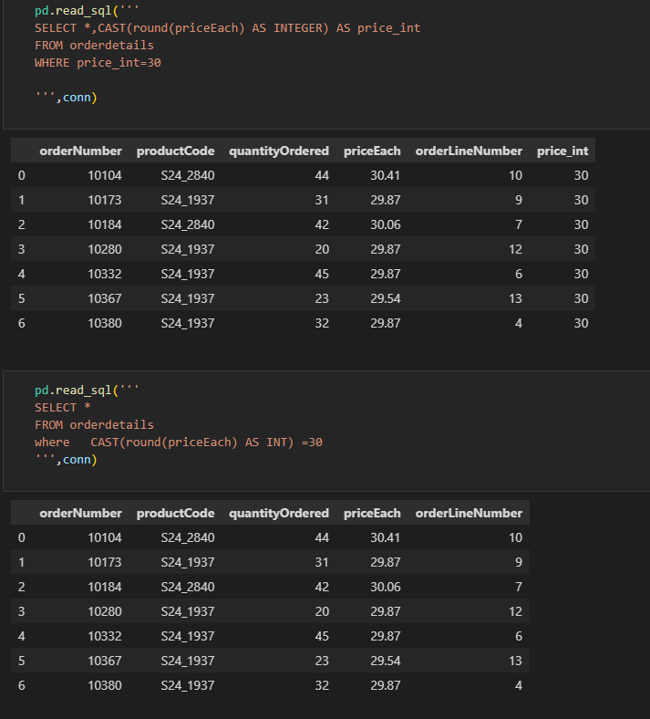

b)**Filter by Date eg select all January orders**

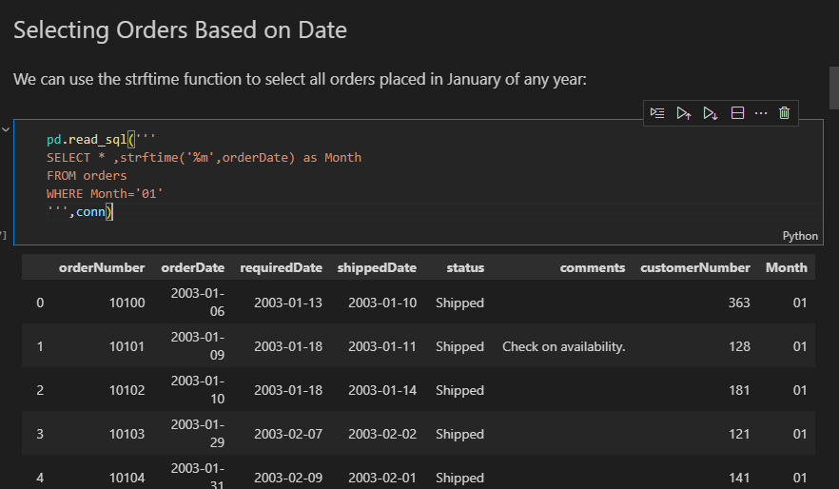

**C)Filter late orders**

pd.read_sql('''

SELECT julianday(shippedDate) - julianday(requiredDate) as days_late ,*

FROM orders

WHERE days_late >0

 ''',conn)

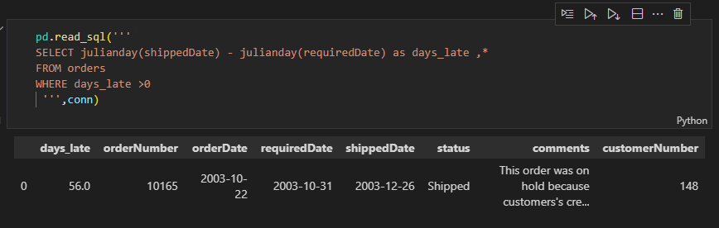

**d)Like –** select cats starting with ‘M’ or ‘m’

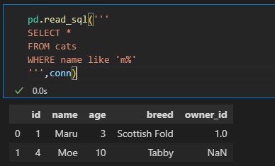

**e) select all cats with four-letter names where the second letter was "a", we could use _a__**

pd.read_sql('''

SELECT *

FROM cats

WHERE name like '_a__'

''',conn)

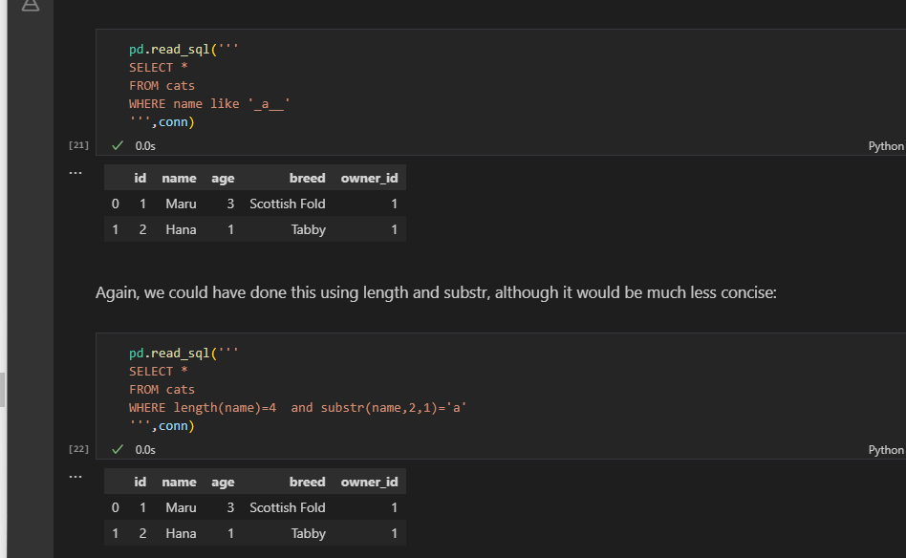

1. Select from 2 tables

pd.read_sql('''

select cats.name,dogs.name

from cats,dogs;

''',conn)

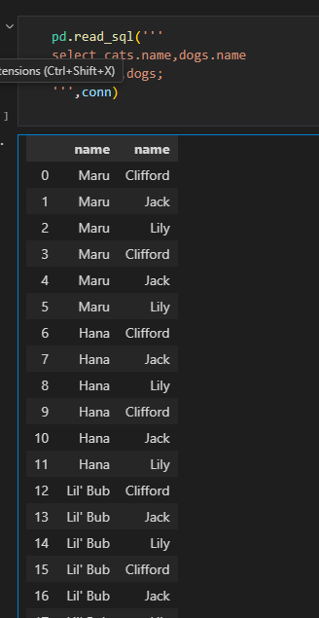

1. way of thinking about which column should come first after ORDER BY, is that the fewer unique values the column has, the earlier it should appear

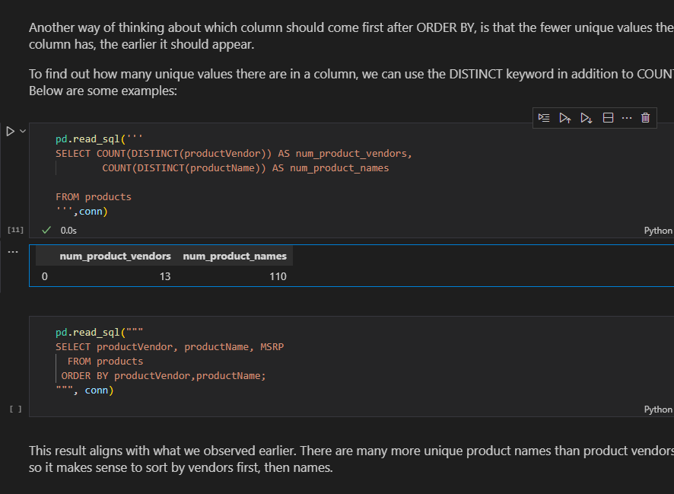

1. Create database and tables

**import sqlite3**

**conn = sqlite3.connect('pets_database.db')**

**cur = conn.cursor()**

a)Create Cats table and insert records

#Creating the cats table

cur.execute('''

CREATE TABLE cats(

            id INTEGER PRIMARY KEY,

            name TEXT,

            age INTEGER,

            breed TEXT

            )

''')

============================================================= cur.execute('''

INSERT INTO cats(name,age,breed)

            VALUES('Maru',3,'Scottish Fold'),

                  ('Lil Bub',2,'Sheperd cat'),

                  ('Hannah',4,'German cats')

''')

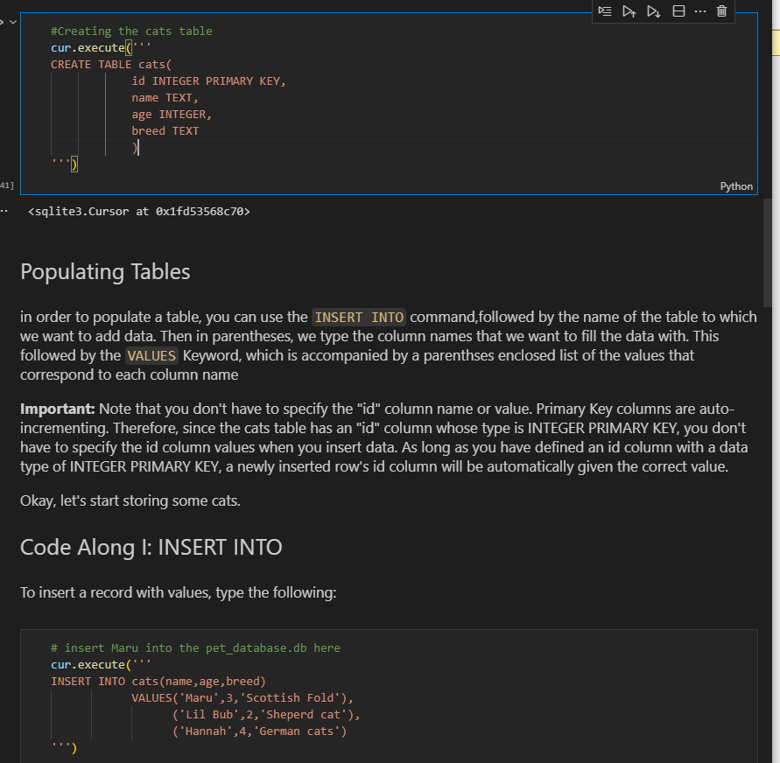

1. Altering(update) and deleting data

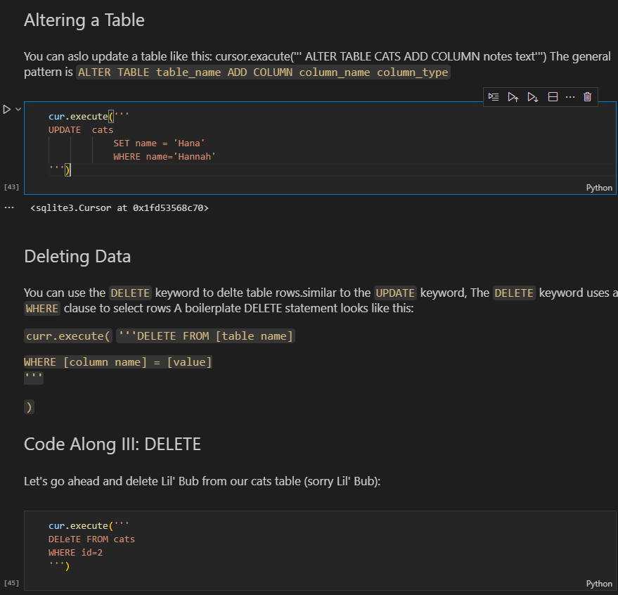

1. We need to save the changes otherwise when we create and new connection and acess record we find that its empty

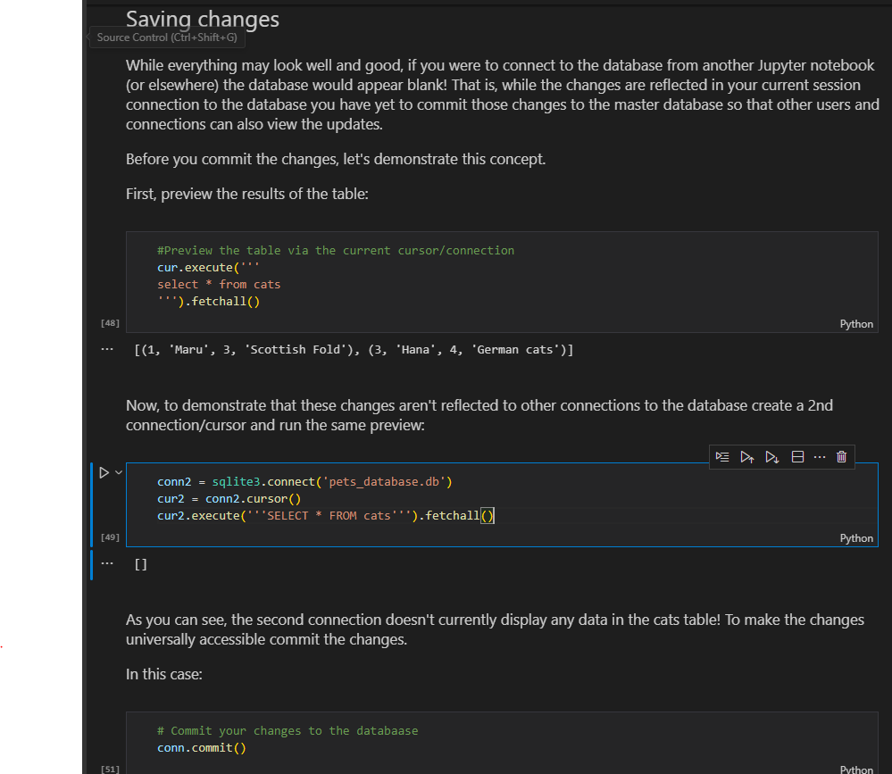

1. Insert into table from dictionary

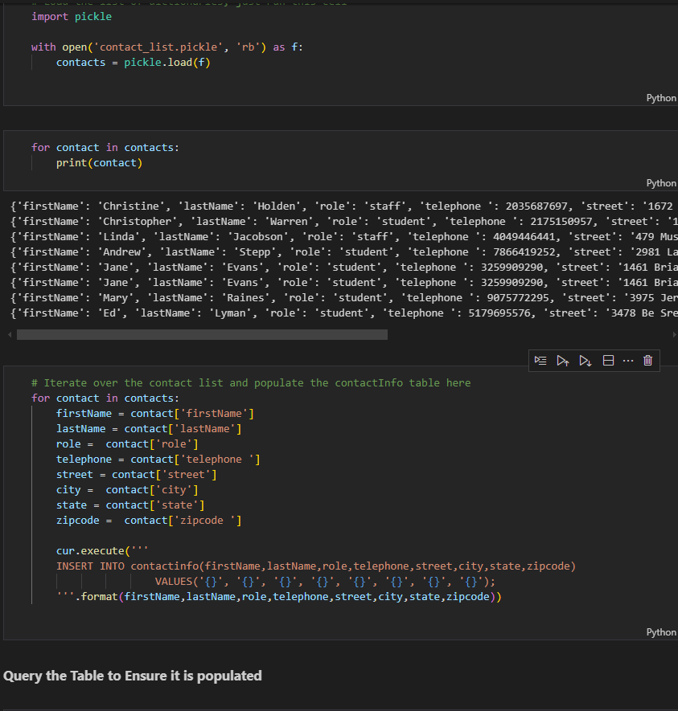

1. Create table with dual key

cur.execute('''

CREATE TABLE Grades(

            userid INTEGER NOT NULL,

            courseid INTEGER NOT NULL,

            grade INTEGER,

            PRIMARY KEY(userid,courseid)

            )

''')

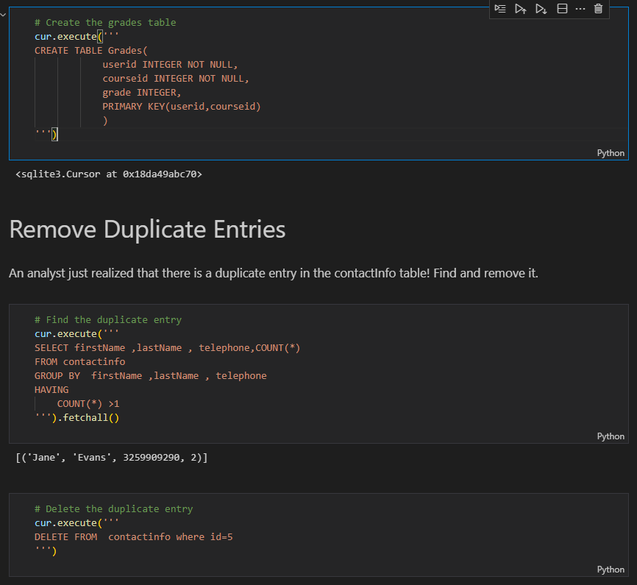

1. **Typing** – the practice of explicitly declaring a type.execises some level of control over our data.Without typig our data can become complicated and messy and it would be difficult to ask the database questions about large sets of data

* TEXT -str
* INTEGER- int
* REAL -float
* BLOB

1. **JOINS**

q= '''

select *

FROM orderdetails

JOIN products

ON orderdetails.productCode = products.productCode

LIMIT 10

'''

pd.read_sql(q,conn)

**b)Columns have the same name**

#IF COLUMNS HAVE THE SAME NAME

q= '''

select *

FROM orderdetails

JOIN products

USING (productCode)

LIMIT 10

'''

pd.read_sql(q,conn)

1. **JOIN IF table is related by joining another table** eg checking how many customers are there per office yet customer does relate to offices but related through employee

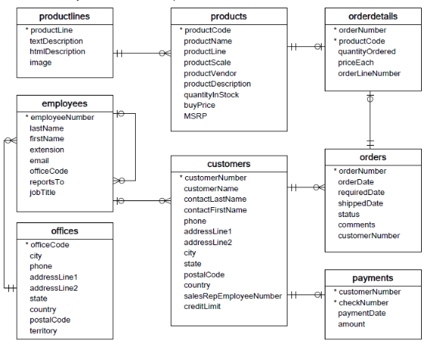q = """

SELECT

    o.officeCode,

    o.city,

    COUNT(c.customerNumber) AS n_customers

FROM offices AS o

JOIN employees AS e

    USING(officeCode)

JOIN customers AS c

    ON e.employeeNumber = c.salesRepEmployeeNumber

GROUP BY officeCode

;

"""

pd.read_sql(q, conn)

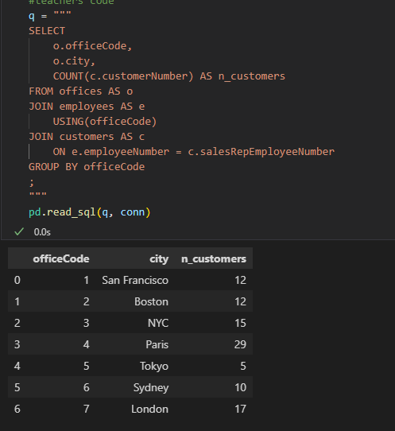

1. **Cast** for numeric purposes

q='''

SELECT

-- Note we have to cast to a numerical value first

MAX(CAST(longitude as REAL)) AS max_longitude

From airports

'''

pd.read_sql(q,conn)

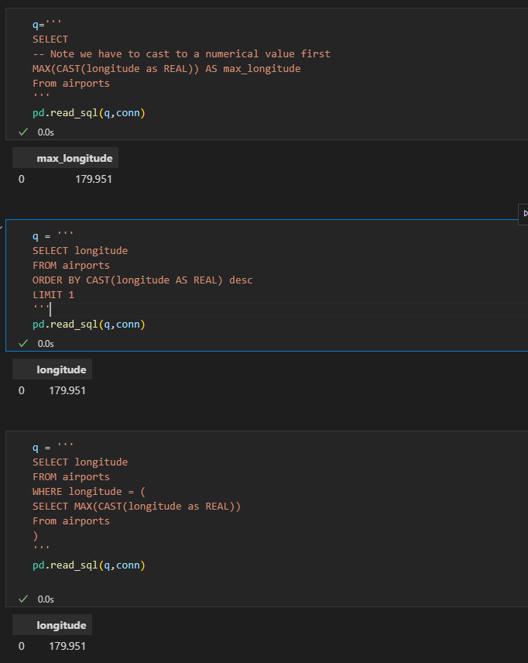

1. Using eval to create new columns

df = df.eval('Age_x_Fare= Age * Fare')

df.head()

1. Querying dataframes with sql(using pandassql)- easier to write than from dataframes

pip install pandasql

from pandasql import sqldf

pysqldf = lambda q: sqldf(q,globals())

q = '''

SELECT name

FROM df

LIMIT 10;

'''

passenger_names = pysqldf(q)

passenger_names

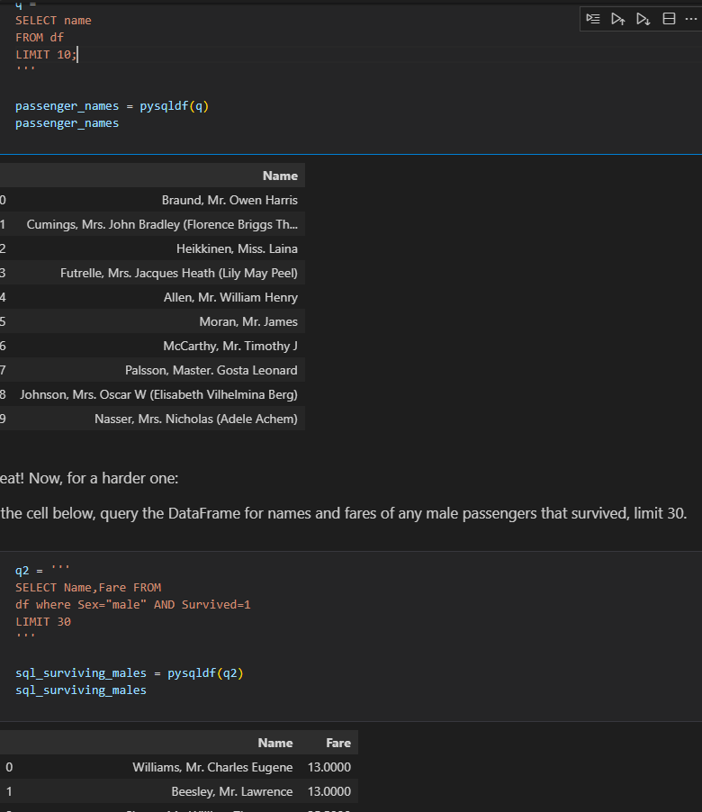

1. **Statistical Distribution** – Representation of the frequencies of potential events or the percentage of time each event occurs.

**a.Discrete Distribution**- Known number of possible outcomes(describes random variables that can take on a countable number of distinct values).use PMF

**Eg**

* Rolling a dice(possible outcomes 1,2,3,4,5,6)
* Number of defective items in a batch
* Count of customers arriving at the store in an hour

**b. Continous Distributions** – infinite no of possible values(describes random variables that can take on an infinite number of values within a given range)

**Eg**

* Heights of individuals
* Time taken to complete a task
* Temperature measurements

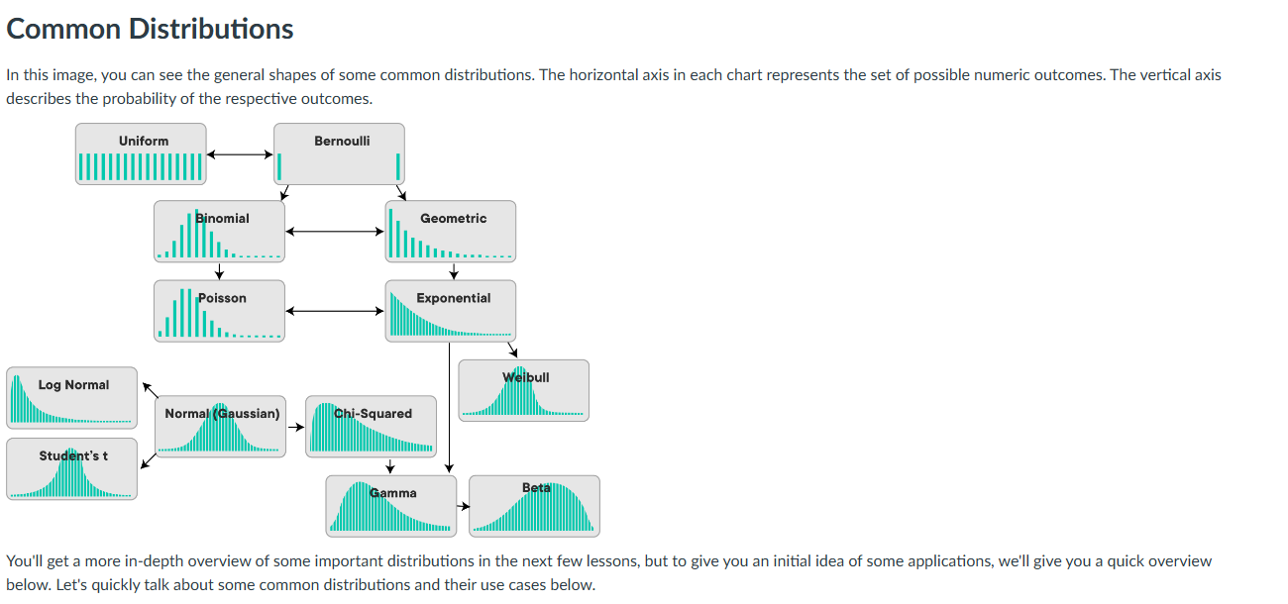

**c. Common distributions and their use cases**

**Examples of Discrete Distributions**

* **The Bernoulli Distribution –** deals with a series of Boolean events eg coin toss
* **Poisson Distribution –** rep the likelihood of a given no of successes over a given period of time. A typical example is pieces of mail. If your overall mail received is constant, the number of items received on a single day (or month) follows a Poisson distribution. Other examples might include visitors to a website, or customers arriving at a store, or clients waiting to be served in a queue.
* **Uniform distribution-** Occurs when all possible outcomes are equally likely eg dice
* **Binomial distribution –** Probability of observing a specific no of successes (Bernoulli trials) in a specific no of trials
* **Geometric**

**Examples of Continuous Distributions**

* **Normal/Gaussian Distribution –** follows a bell shape and is a foundational distribution for many models and theories un statistics and data science. A normal distribution turns up very often when dealing with real-world data including heights, weights of different people, errors in some measurement or grades on a test. Our temperature example above follows a normal distribution as well!
* **Exponential –**  rep the amt of time it takes before an event occurs
* **Continous uniform**

1. **Population** -Whole set of possible outcomes(universal set)
2. **Sample** – subset of the population

**Reasons we cant observe a whole group/population**

* Expensive(not enough fuding)
* Unrealistic (grp too large)
* We don’t need a whole population to gain insights
* People not willing to give info
* A large enough sample has mean close to the population mean,small samples can be misleading
* Sample means with multiple samples has mean close to the population mean

1. **Descriptive statistics** – summary metrics that describe and summarize the main features of a dataset. They help in understanding the basic aspects of the data by providing quantitative descriptions eg meausures of central tendency(mean,mode, median),measures of dispersion/spread eg(variance. Std,IQR) and measures of shape(skweness and kurtosis)

-We use visualizations such as histograms and boxpplots to understand the shape of the distributions

**Population statisctics**- when descriptive statistics are applied to populations

**Point estimates**- descriptive statisctics applied to samples

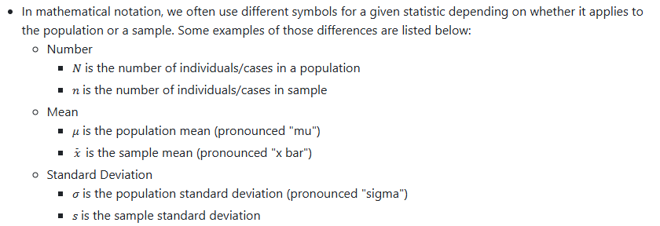

1. **Probability Mass Function(PMF) –** Used for discrete random variables.It gives the probability that a discrete random variable is exacly equal to a specific value.

**PMF Intuition -** Probability is a number in the range [0,1] that is calculated as the frequency expressed as fraction of the sample size

**-**In order to convert any random variables frequency into a probability we need to perform the following steps

* Get the frequency of each possible value in te dataset
* Divide the frequency of ach value by the total number of values(length of the dataset
* Get the probability of each value

**EXAMPLE1**

**Simple toy example**

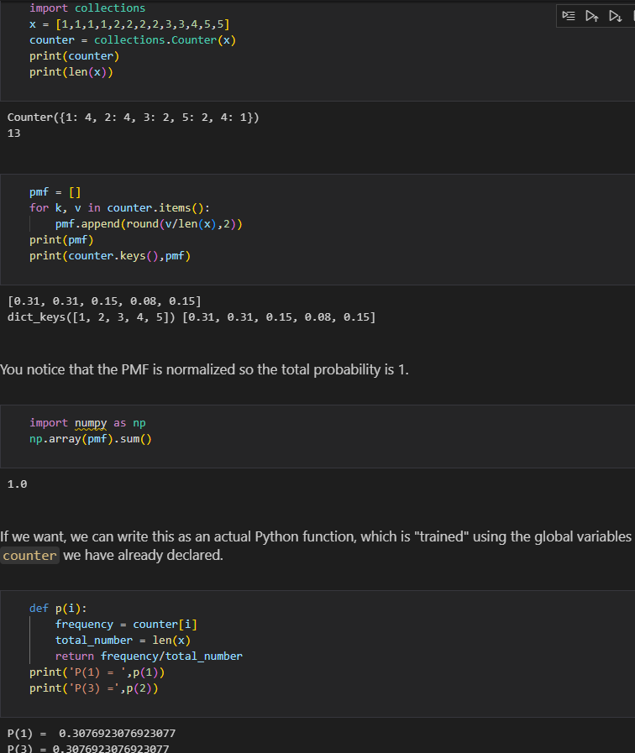

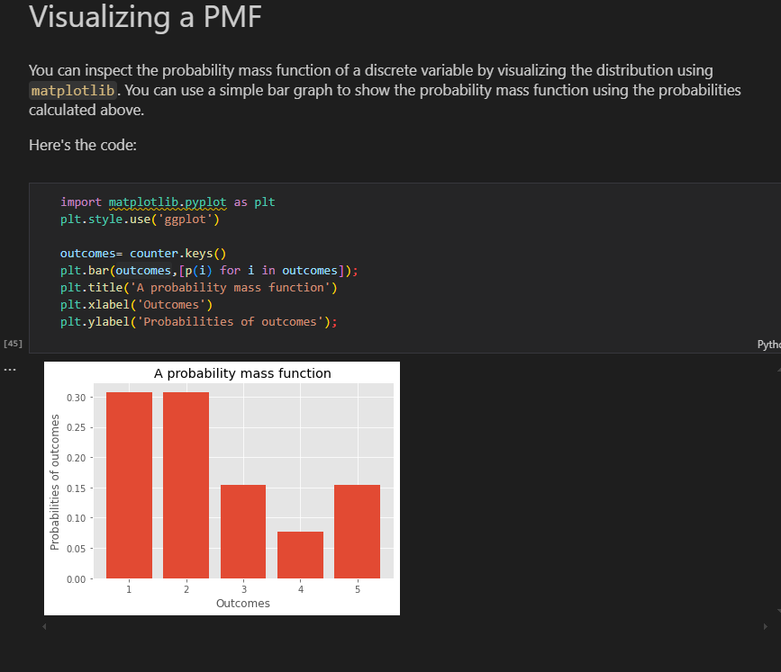

**-**Can use histogram as well but include desnsity =true

plt.hist(x,bins=bins,rwidth=0.25,density=True)

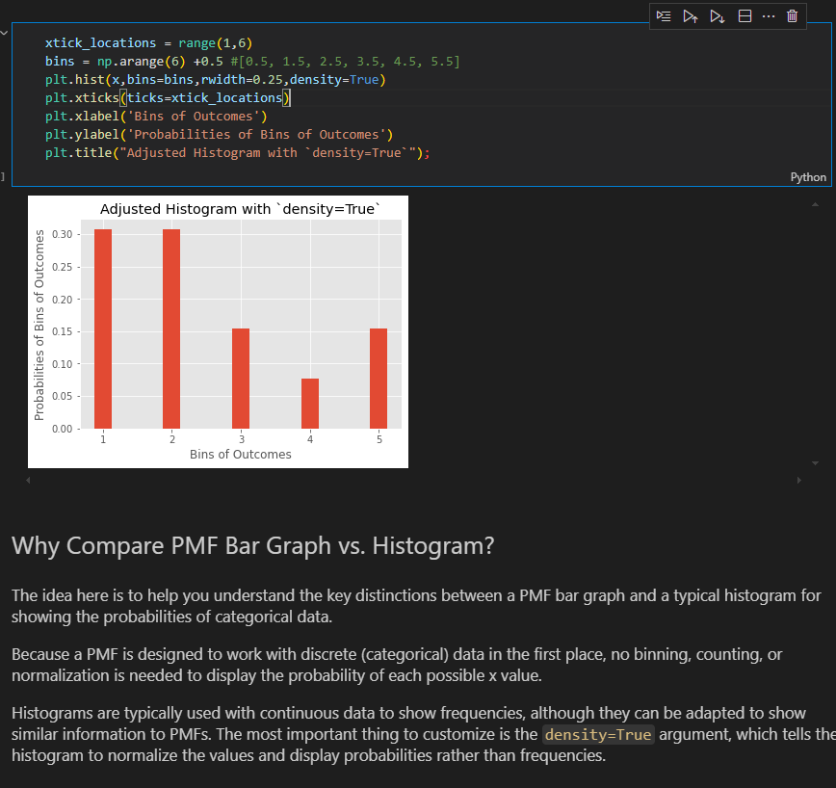

**EXAMPLE 2(Titanic dataset)**

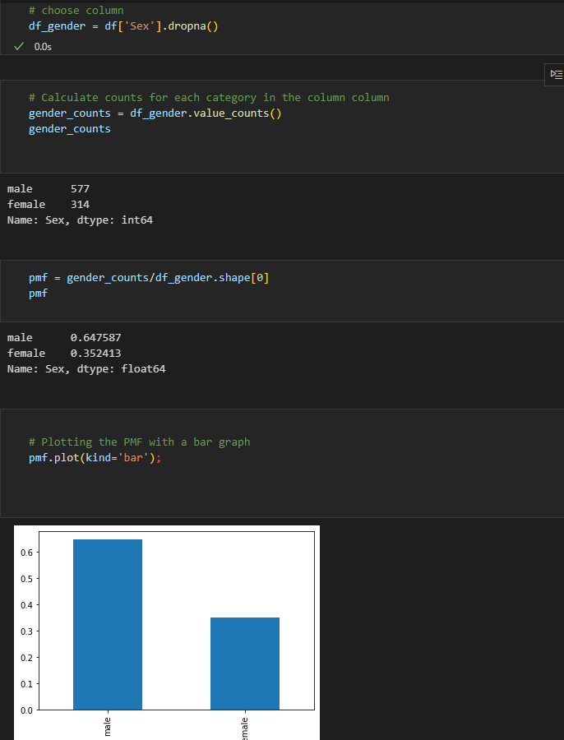

1. **Probability Density Function(PDF)** – used for continuous random variables. It describes the likelihood of the variable falling within a particular range of values , rather than taking on a specific value

**PDF Intution**-

**1. Concept of Density**

**\*\*Continuous Variables\*\***: Unlike discrete variables, continuous variables can take on an infinite number of values within a given range (e.g., heights, weights). Therefore, we can't assign a probability to a specific value (e.g., the probability of someone being exactly 170 cm tall is zero).

    Density: Instead, the PDF represents the density of probabilities. Higher values of the PDF at a point indicate a higher likelihood of the random variable being near that value.

**2. Area Under the Curve**

**\*\*Probability as Area:\*\*** The PDF itself does not give probabilities directly; instead, probabilities are found by calculating the area under the curve of the PDF over a specific interval. For instance, the probability that a random variable X falls between a and b is given by:

    P(a<X<b)=∫ab​f(x)dx

**3. Total Area Equals One**

**\*\*Normalization\*\***: The total area under the PDF curve is always equal to 1. This reflects the fact that the random variable must take on some value within the range of possible values.

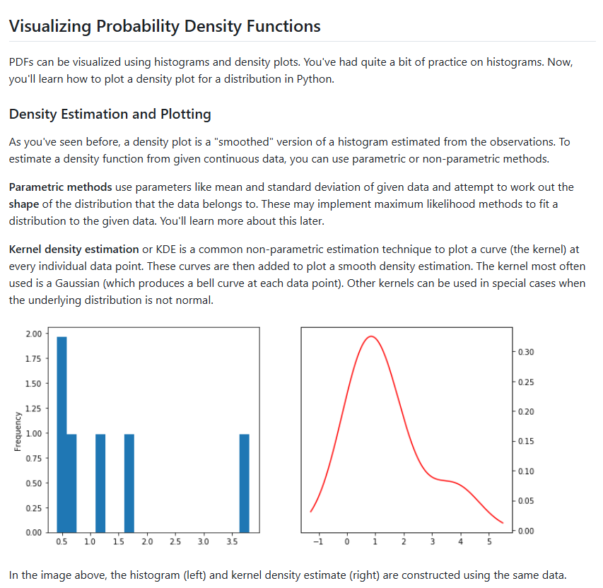

**EXAMPLE:TITANIC DATA SET**

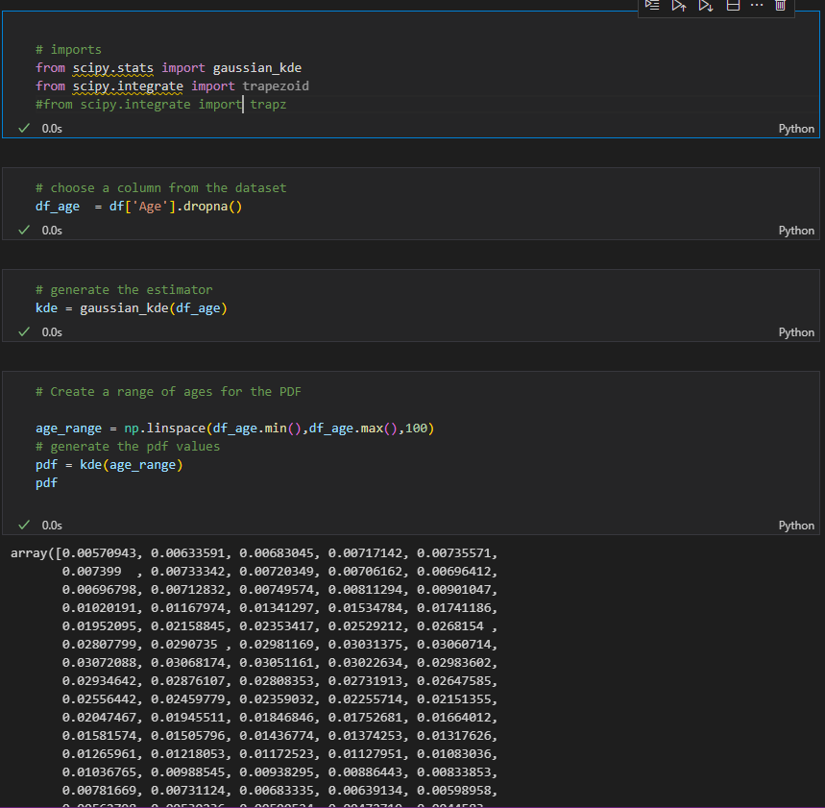

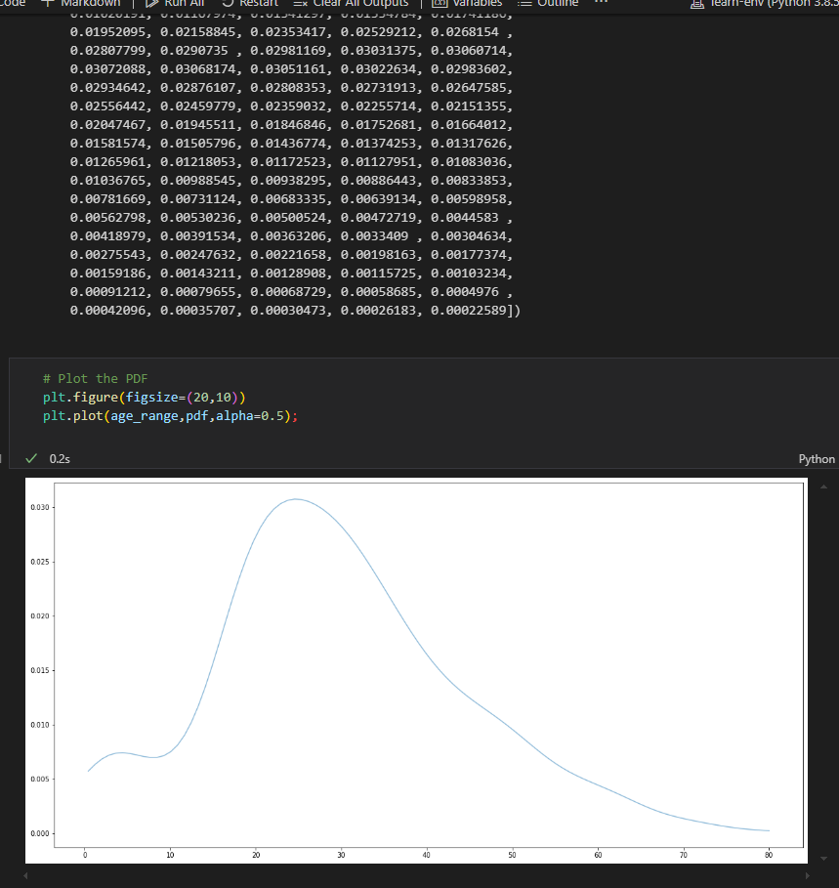

1. **CUMULATIVE DISTRIBUTION FUNCTION (CDF)-** provides a way to describe the probability distribution of a random variable

Gives the probability that variable X is less than or equal to a certain possible value of x

**Properties of CDF**

* Non-decreasing – CDF is always non-decreasing;as x increases,f(x) either increases or stays the same
* Range- CDF takes values in the range [0,1]
* Right-continous- CDF approaches its limit from the right

**EXAMPLE 1: CONT from titanic dataset**

1. sort data

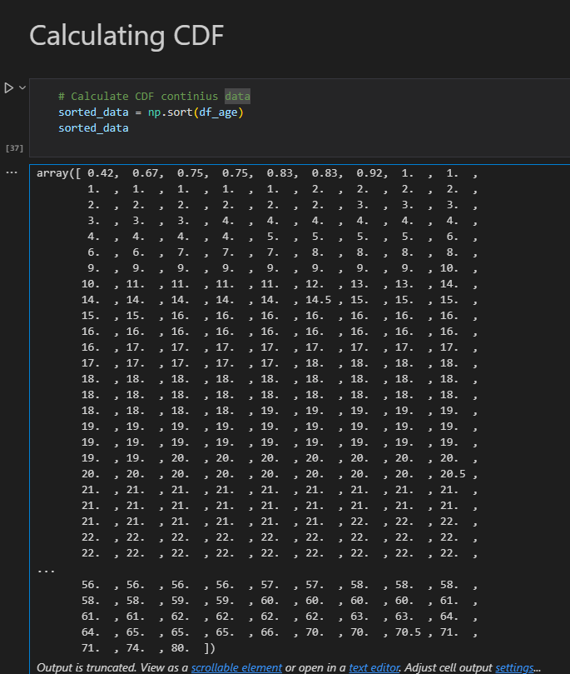

1. Do a cumulative sum and calculate cdf

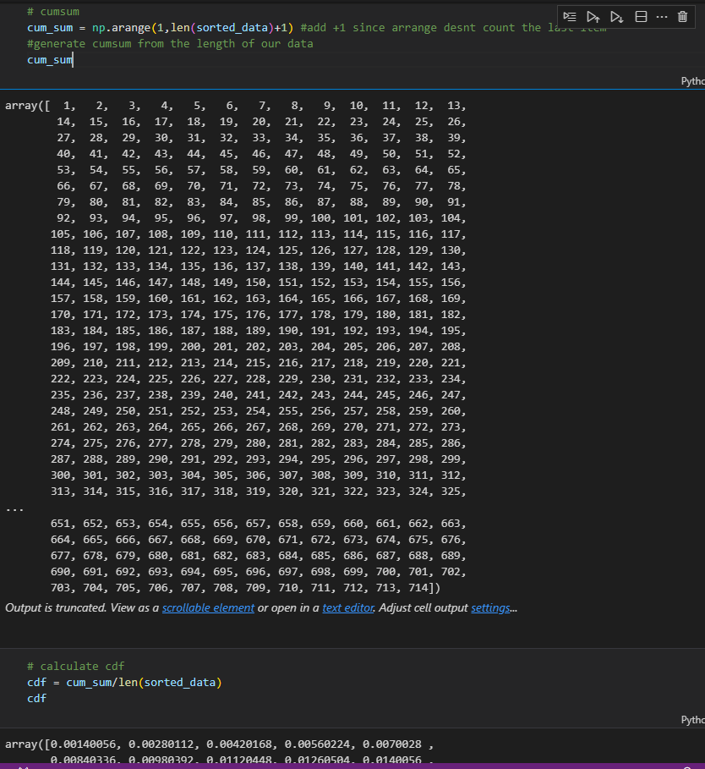

3.Plot

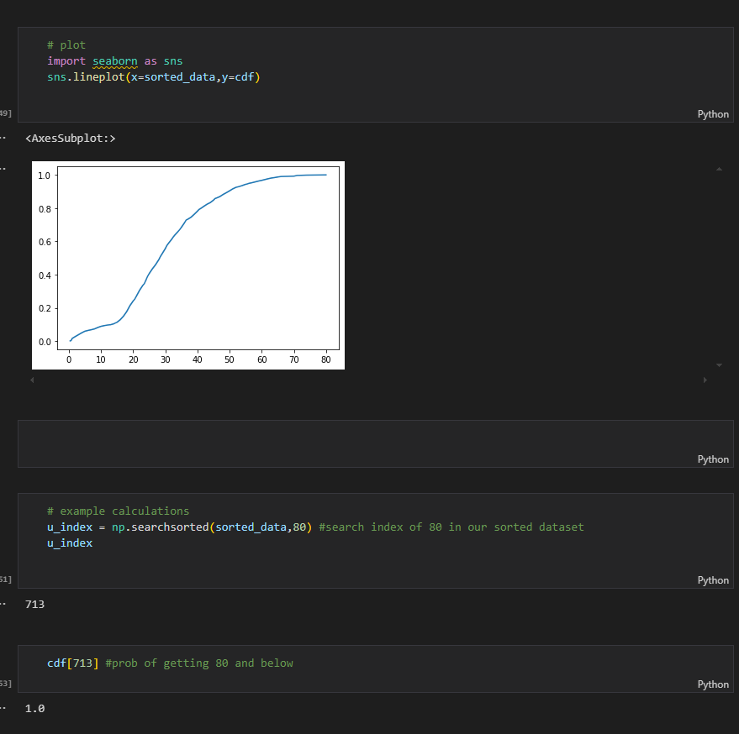

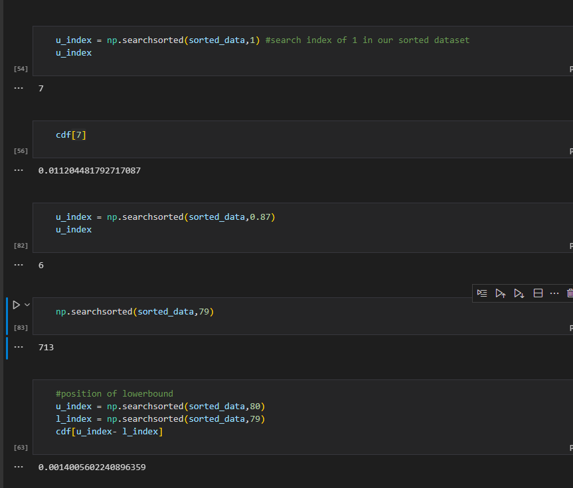

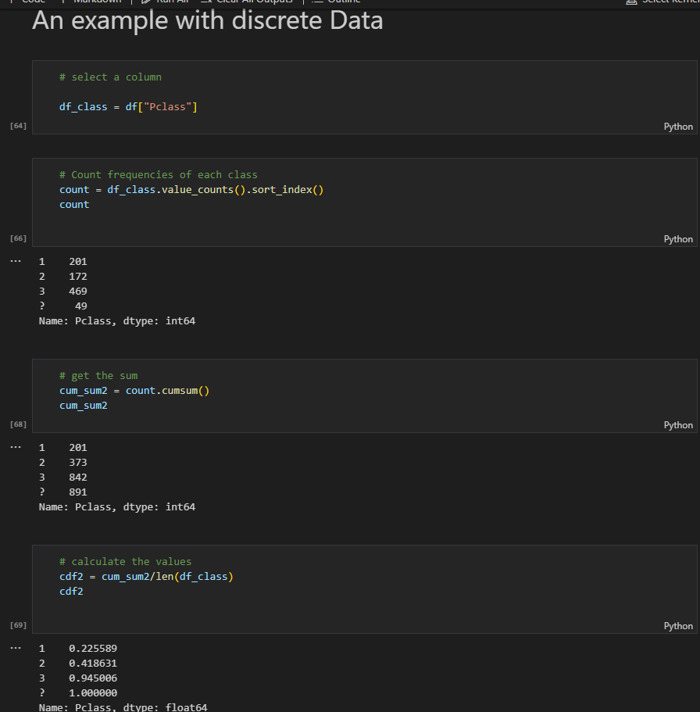

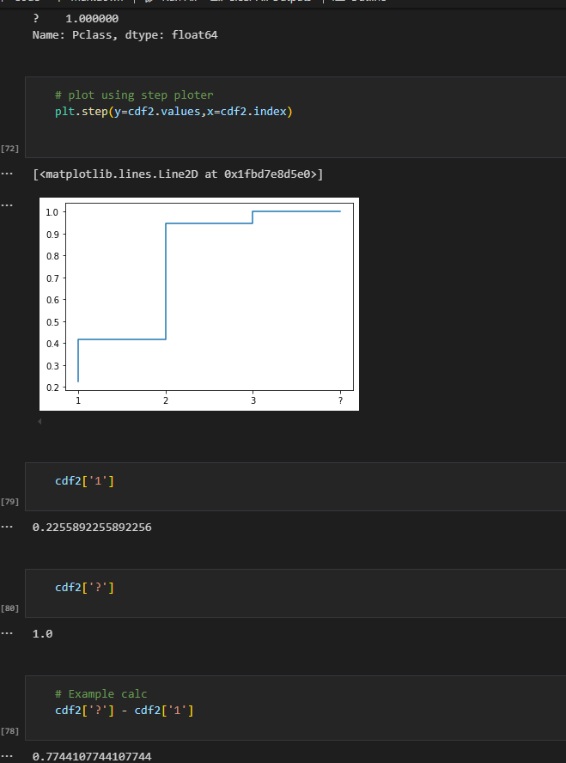

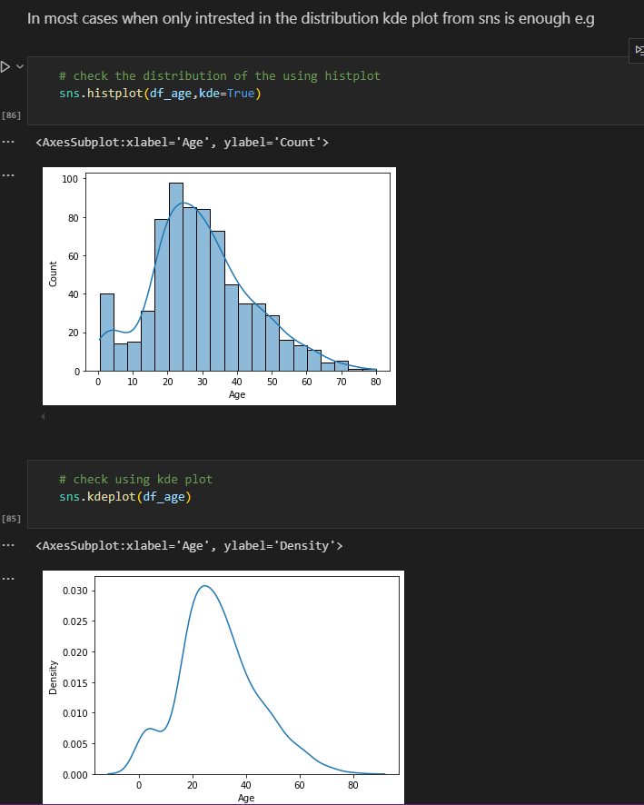

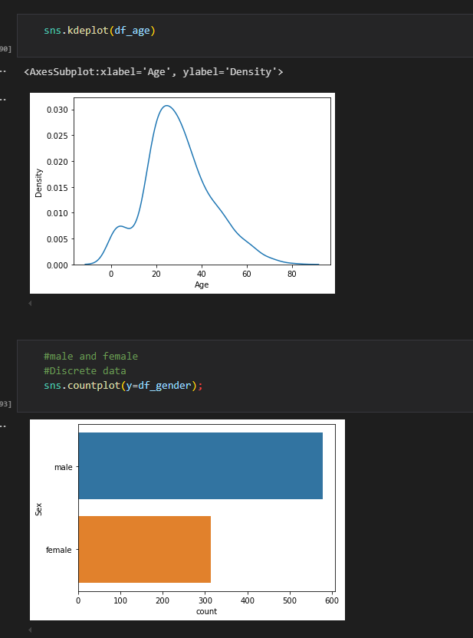

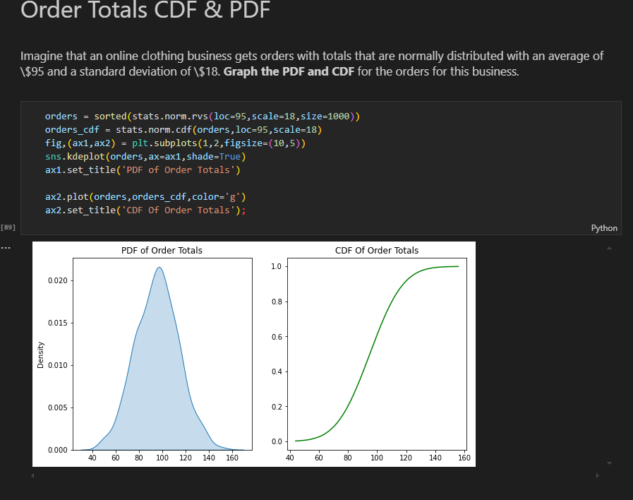

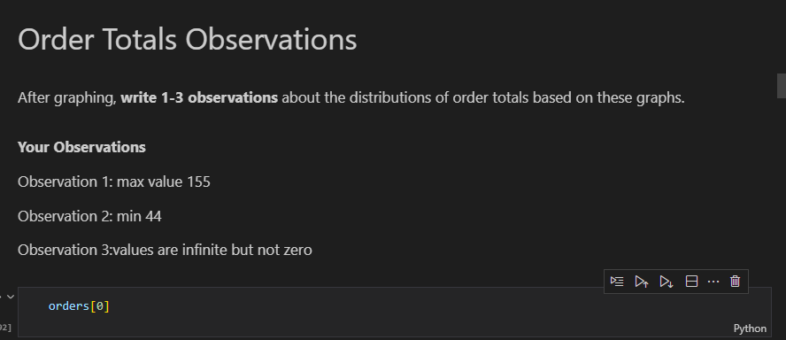

HISTOGRAM AND CDF

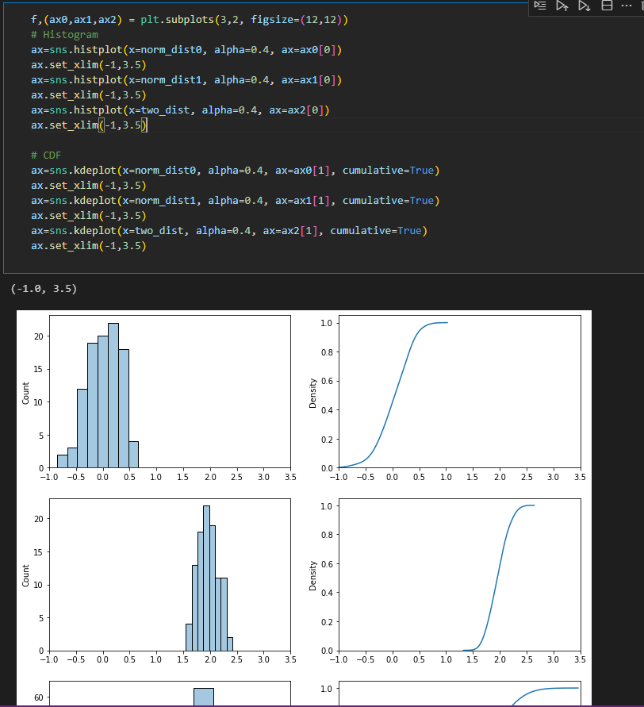

1. **Normal Distributions/Gaussian Distribution** - is defined by two parameters: the mean (μ) and the standard deviation (σ). The mean determines the center of the distribution, while the standard deviation measures the dispersion or spread of the data points around the mean. The probability density function

* The curve is symmetric about the mean, meaning that approximately 68% of the data lies within one standard deviation (σ) from the mean, about 95% within two standard deviations, and about 99.7% within three standard deviations. This is often referred to as the empirical rule or the 68-95-99.7 rule.

**Importance in Statistics**

* The normal distribution holds a central place in statistics for several reasons:
* Central Limit Theorem: One of the most significant reasons for the prominence of the normal distribution is the Central Limit Theorem (CLT). The CLT states that the distribution of the sample means will tend to be normally distributed, regardless of the original distribution of the data, as long as the sample size is sufficiently large. This makes the normal distribution a key tool for inferential statistics.
* Statistical Inference: Many statistical tests and methods, including t-tests, ANOVA, and regression analysis, assume that the underlying data is normally distributed. This assumption allows for the application of parametric tests, which can provide more powerful results than non-parametric alternatives.
* Natural Phenomena: Numerous real-world measurements—such as heights, weights, test scores, and measurement errors—tend to follow a normal distribution. This natural occurrence in various fields, including psychology, biology, and economics, makes the normal distribution a useful model for analyzing data

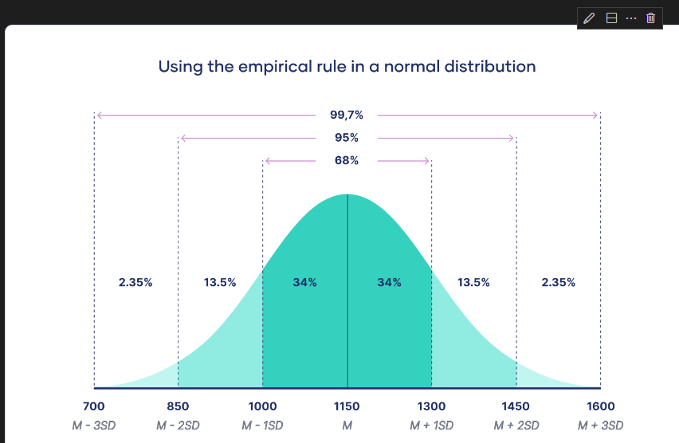

**X-Stics of Normal Distribution**

**1. Symmetry**- Bell-Shaped Curve: The normal distribution is symmetric about the mean (μ). This means that the left side of the curve is a mirror image of the right side. Mean = Median = Mode: In a normal distribution, the mean, median, and mode are all located at the center of the distribution.

**2. Defined by Mean and Standard Deviation-** Mean (μ): The average value around which the data points are distributed. It determines the center of the distribution.

 Standard Deviation (σ): This measures the spread or dispersion of the data. A smaller standard deviation results in a steeper curve, while a larger standard deviation produces a flatter curve.

**3. Empirical Rule (68-95-99.7 Rule)-**  68% of Data within 1 Standard Deviation: Approximately 68% of the data falls within one standard deviation (σ) of the mean (μ).

  95% within 2 Standard Deviations: About 95% of the data lies within two standard deviations.

   99.7% within 3 Standard Deviations: Nearly all (99.7%) of the data is within three standard deviations from the mean.

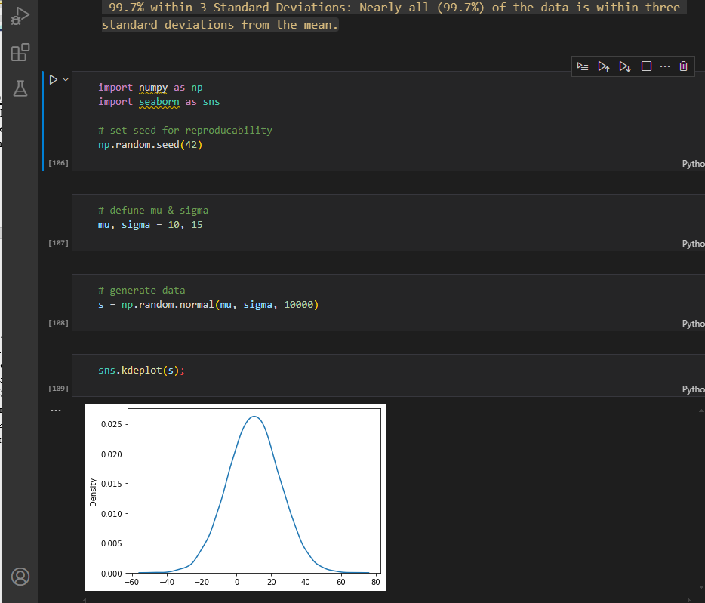

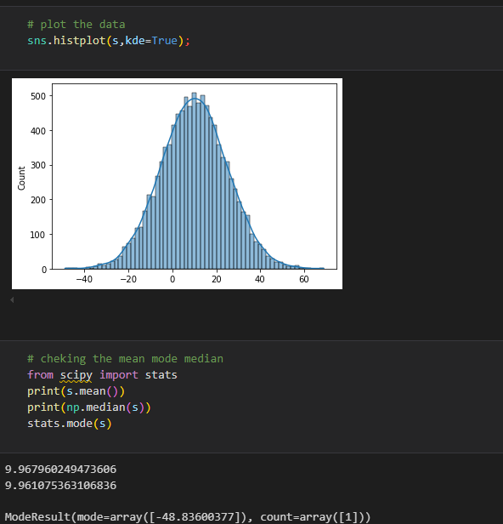

1. **Standard Normal Distribution**- Special case of the normal distribution that has been standardized to simplify analysis and interpretation.Its crucial in statisctics due to its properties and its role in various statisctical methods.

Special case of normal distribution with a mean of 0 and std of 1

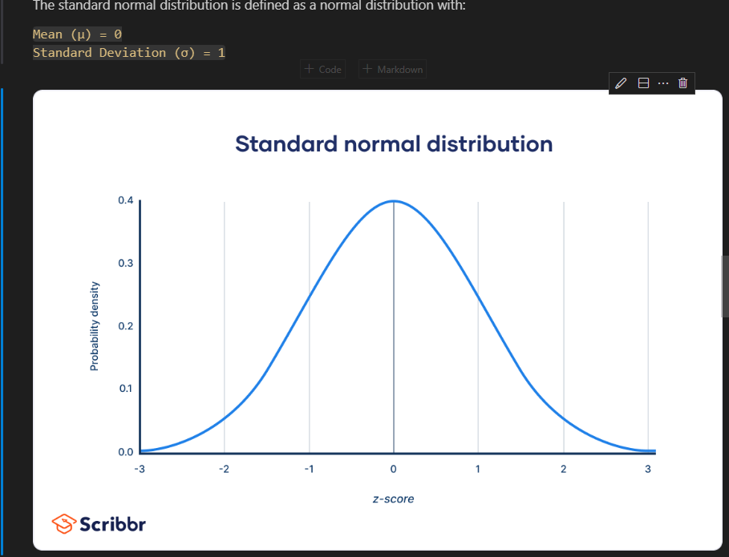

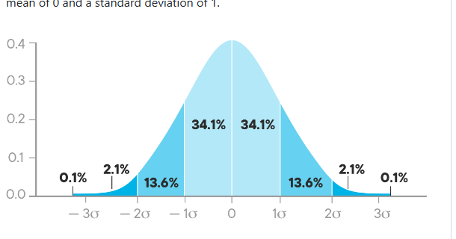

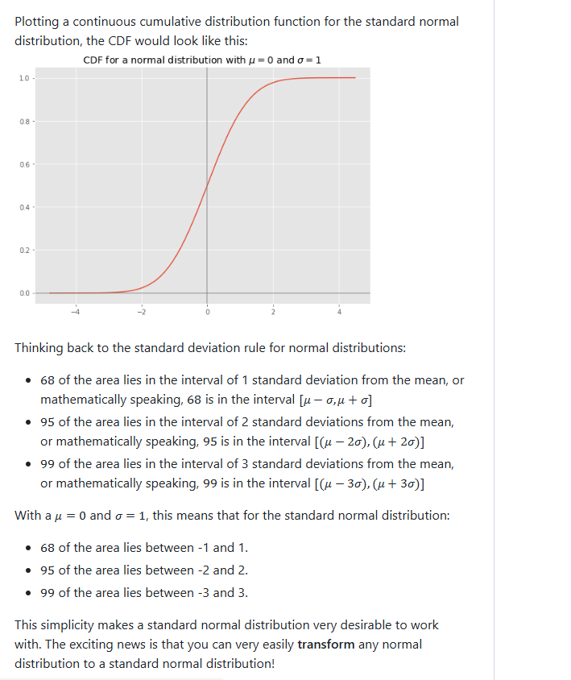

**a)Standard score/z-score –** Statisctical measurement that describes a value’s relation to the mean of a group of values.It indicates how many standard deviations a data point is from the mean of the dataset

**z=(X−μ)/σ**

Where:

    X is the value in question.

    μ is the mean of the dataset.

    σ is the standard deviation of the dataset.

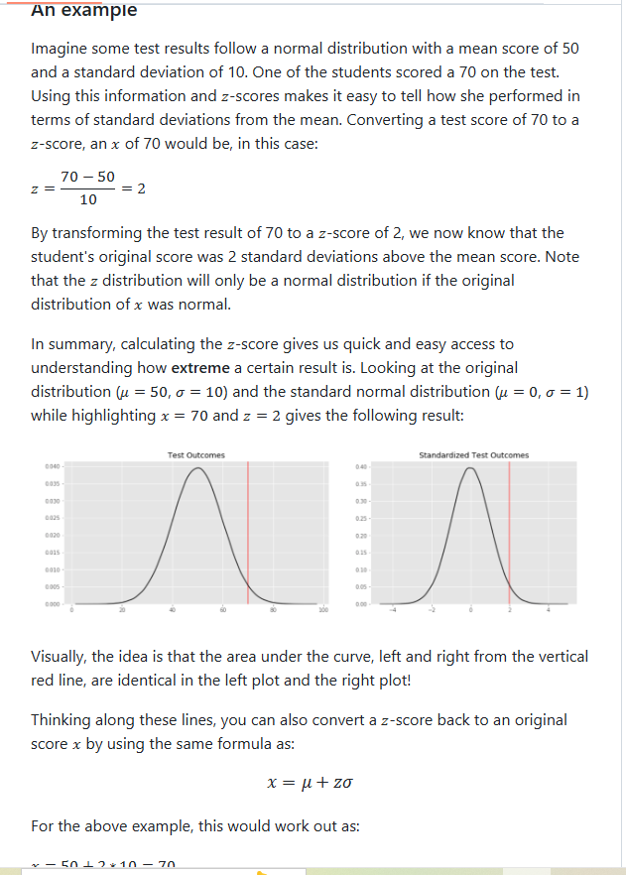

**b. Data Standardization –** common data preprocessing skill, which is used to compare a number of observations belonging to the different normal distributions which may have distinct means and standard deviations

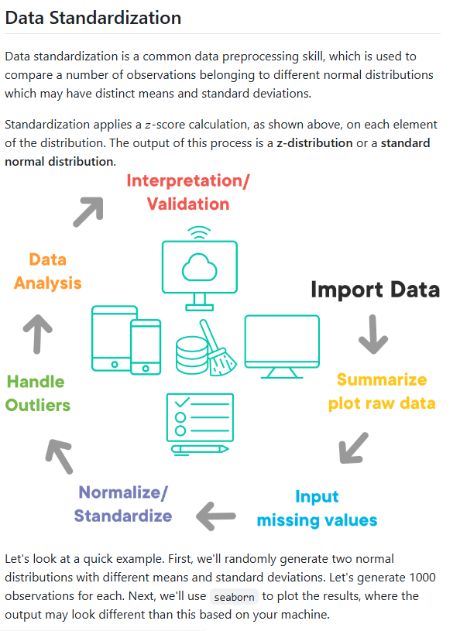

import numpy as np

import seaborn as sns

mean1,sd1 = 5,3 #dist1

mean2,sd2 = 10,2 #dist 2

d1 = np.random.normal(mean1,sd1,1000)

d2 = np.random.normal(mean2,sd2,1000)

sns.histplot(d1,alpha=0.2,color='b',kde=True,stat='density')

sns.histplot(d2,alpha=0.2,color='orange',kde=True,stat='density');

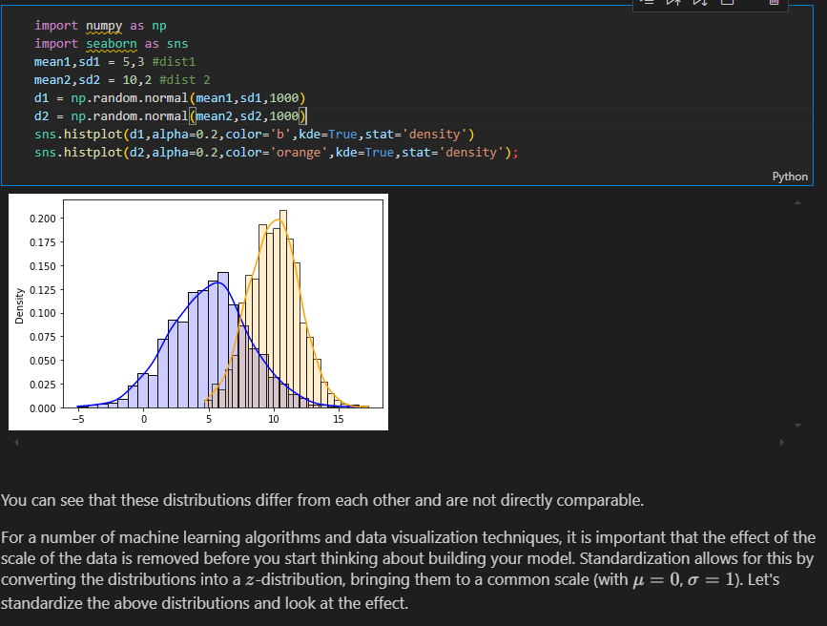

**TEACHERS CODE using kde instead of stat**

sns.histplot(d1,kde=True,alpha=0.2,color="blue",edgecolor='none')

sns.histplot(d2,kde=True,alpha=0.5,color="green",edgecolor='none')

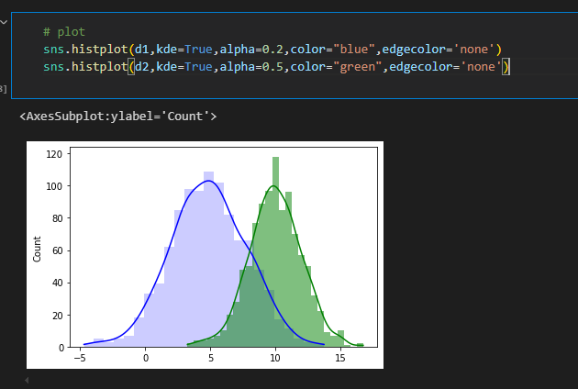

**AFTER STANDARDIZATION**

# Stardardizing and visualizing distributions

sns.histplot([(x - d1.mean())/d1.std() for x in d1],alpha=0.2,color='b',kde=True,stat='density');

sns.histplot([(x - d2.mean())/d2.std() for x in d2],alpha=0.2,color='orange',kde=True,stat='density');

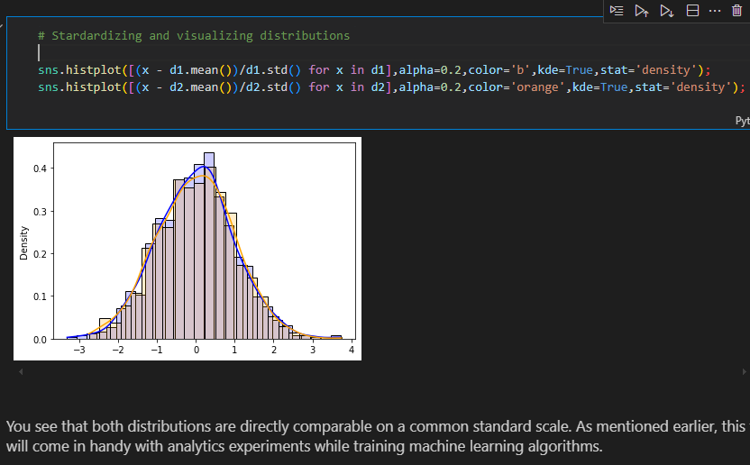

**Teachers code without stat**

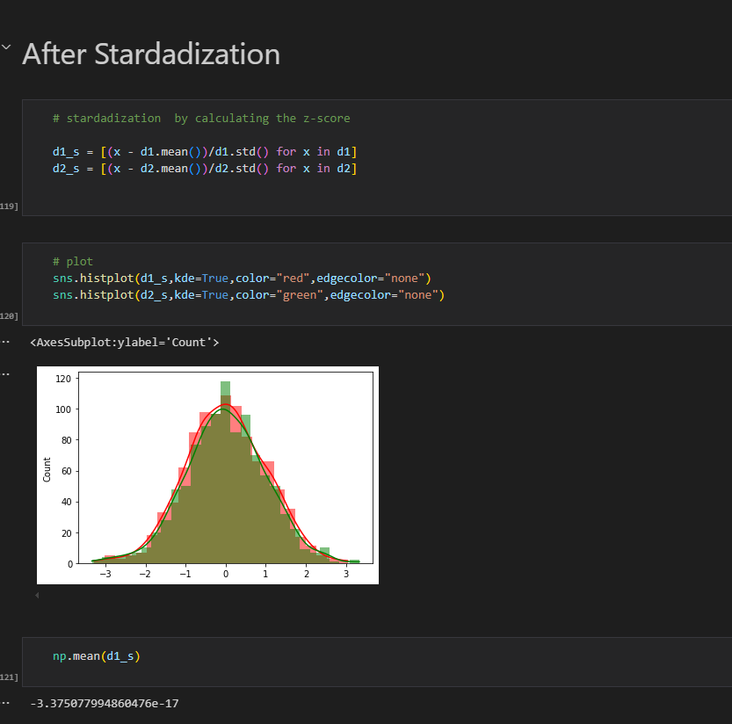

1. The **z-score** can be used to understand how extreme a certain result is
2. **Skewness** and **kurtosis** can be used to measure how different a given distribution is from a normal distribution

**Examples of z scores**

